**AYUSH SERVICES AVAILABILITY APP**

**HDAN**

*Submitted for partial fulfillment of the requirements*

*for the award of*

**BACHELOR OF TECHNOLOGY**

**in**

**COMPUTER SCIENCE ENGINEERING - ARTIFICIAL INTELLIGENCE & MACHINE LEARNING**

by

**Saisrija Alapati** - **20BQ1A4202**

**Pragathi Darla** - **20BQ1A4215**

**Deepak Bade** - **20BQ1A4205**

**Divya Gunjara** - **20BQ1A4223**

Under the guidance of

1. **Gnanendra, M.Tech(Ph.D)**

**Assistant Professor**



**DEPARTMENT OF COMPUTER SCIENCE ENGINEERING - ARTIFICIAL INTELLIGENCE & MACHINE LEARNING**

**VASIREDDY VENKATADRI INSTITUTE OF TECHNOLOGY**

Permanently Affiliated to JNTU Kakinada, Approved by AICTE

Accredited by NAAC with ‘A’ Grade, ISO 9001:2008 Certified

NAMBUR (V), PEDAKAKANI (M), GUNTUR – 522 508

Tel no: 0863-2118036, url: [www.vvitguntur.com](http://www.vvitguntur.com)

April 2024

**VASIREDDY VENKATADRI INSTITUTE OF TECHNOLOGY**

Permanently Affiliated to JNTUK, Kakinada, Approved by AICTE

Accredited by NAAC with ‘A’ Grade, ISO 9001:20008 Certified

Nambur, Pedakakani (M), Guntur (Gt) -522508

**DEPARTMENT OF COMPUTER SCIENCE ENGINEERING - ARTIFICIAL INTELLIGENCE& MACHINE LEARNING**

**CERTIFICATE**

This is to certify that this **Project Report** is the bonafide work of **Ms. Saisrija Alapati, Ms. Pragathi Darla, Mr. Deepak Bade, Ms. Divya Gunjara** bearing Reg. No. **20BQ1A4202, 20BQ1A4215, 20BQ1A4205, 20BQ1A4223** respectivelywho had carried out the project entitled **“Ayush Services Availability App - HDAN"** under our supervision.

**Project Guide Head of the Department**

1. Gnanendra, Assistant Professor) (Dr. K. Suresh Babu, Professor)

**Submitted for Viva voce Examination held on \_\_\_\_\_\_\_\_\_\_\_\_\_\_\_\_\_\_\_\_\_\_\_\_\_\_\_\_**

**Internal Examiner External Examiner**

**DECLARATION**

We, Ms. Saisrija Alapati, Ms. Pragathi Darla, Mr. Deepak Bade, Ms.Divya Gunjara, hereby declare that the Project Report entitled **“Ayush Services Availability App - HDAN”** done by us under the guidance of K. Gnanendra, Assistant Professor, Computer Science Engineering - Artificial Intelligence & Machine Learning at Vasireddy Venkatadri Institute of Technology is submitted for partial fulfillment of the requirements for the award of Bachelor of Technology in Computer Science Engineering - Artificial Intelligence & Machine Learning. The results embodied in this report have not been submitted to any other University for the award of any degree.

DATE :

PLACE :

SIGNATURE OF THE CANDIDATE (S)

**ACKNOWLEDGEMENT**

We take this opportunity to express my deepest gratitude and appreciation to all those people who made this project work easier with words of encouragement, motivation, discipline, and faith by offering different places to look to expand my ideas and helped me towards the successful completion of this project work.

First and foremost, we express my deep gratitude to **Mr. Vasireddy Vidya Sagar**, Chairman, Vasireddy Venkatadri Institute of Technology for providing necessary facilities throughout the B.Tech programme.

We express my sincere thanks to **Dr. Y. Mallikarjuna Reddy**, Principal, Vasireddy Venkatadri Institute of Technology for his constant support and cooperation throughout the B.Tech programme.

We express my sincere gratitude to **Dr. K. Suresh Babu**, Professor & HOD, Computer Science Engineering - Artificial Intelligence & Machine Learning, Vasireddy Venkatadri Institute of Technology for his constant encouragement, motivation and faith by offering different places to look to expand my ideas.

We would like to express my sincere gratefulness to our Guide **K. Gnanendra**, Assistant Professor, Computer Science Engineering - Artificial Intelligence & Machine Learningfor his insightful advice, motivating suggestions, invaluable guidance, help and support in successful completion of this project.

We would like to express our sincere heartfelt thanks to our Project Coordinator

1. **Balayesu,** Assistant Professor, Computer Science Engineering - Artificial Intelligence & Machine Learning for his valuable advices, motivating suggestions, moral support, help and coordination among us in successful completion of this project.

We would like to take this opportunity to express my thanks to the **Teaching and Non-Teaching** Staff in the Department of Computer Science Engineering - Artificial Intelligence & Machine Learning, VVIT for their invaluable help and support.

**Name (s) of Students**

**TABLE OF CONTENTS**

**CH No Title Page No**

Table of Contents I

List of Figures III

List of Tables V

Abstract VI

**1 INTRODUCTION**

1.1 What is AYUSH? 1

1.2 What is Image Recognition 2

1.3 Image Recognition Usecases 3

1.4 Image Recognition Techniques 4

1.5 Problem Statement 10

1.6 Objective of the Project 10

1.7 Scope 10

1.8 Project Introduction 10

1.9 Process 11

1.10 Features 11

1.11 Existing System 11

1.12 K-Nearest Neighbor Algorithm 12

1.13 Convolutional Neural Networks 14

**2 REVIEW OF LITERATURE** 18

**3 PROPOSED SOLUTION**

3.1 Overview 20

3.2 Proposed System 20

3.3 Functional requirements for proposed system 21

3.4 Proposed system Architecture 22

3.5 System Design 22

3.6 UML Diagrams 23

3.7 Process 30

**4 IMPLEMENTATION**

4.1 Software Installation

4.1.1 Software Installation for JDK Kit 31

4.1.2 Android Studio IDE and SDK Installation 33

4.2 Android Architecture 40

**5 RESULTS**

5.1 Test Strategy and Approach 44

5.2 Final Application Screens 46

**6 CONCLUSION AND FUTURE SCOPE** 52

**7 REFERENCES**  53

**APPENDIX**

Published Article Certificates 54

Published Article in the Journal 58

**LIST OF FIGURES**

**Figure No Figure Name Page No**

1.1 Image Recognition Roadmap 4

1.2 Collected Tulasi Dataset 5

1.3 Collected Vasaka Dataset 6

1.4 Collected Neem Dataset 6

1.5 Collected Cardamom Dataset 6

1.6 Collected Bhringaraj Dataset 6

1.7 Collected Ashwagandha Dataset 7

1.8 Pixel representation of digital image 8

1.9 Working of convolutional neural networks in image recognition 8

1.10 Steps for Image Recognition 12

1.11 KNN Algorithm Working Visualization 12

1.12 KNN Algorithm Working 13

1.13 CNN Architecture 15

1.14 Dimensions of example image 15

1.15 Process of Convolution 16

3.1 System Flowchart 21

3.2 Proposed system Architecture 22

3.3 Usecase Diagram 23

3.4 Class Diagram 24

3.5 Sequence Diagram 25

3.6 Collaboration Diagram 26

3.7 Activity Diagram 27

3.8 Component Diagram 28

3.9 Deployment Diagram 28

3.10 ER Diagram 28

3.11 Data Flow Diagram 29

3.12 Agile Methodology Life cycle 30

4.1 Java Installation Screen 32

4.2 Android Architecture 40

5.1 App Opening Page 47

5.2 Login Page 47

5.3 New User Registration Page 47

5.4 Admin Dashboard 47

5.5 Admin -> Yogamaster 48

5.6 Admin -> Doctors 48

5.7 Admin -> Users 48

5.8 User Feedbacks 48

5.9 Doctor Dashboard 49

5.10 Doctor -> Appointment 49

5.11 User Dashboard 49

5.12 User -> Ayurveda Products 49

5.13 User -> Ayurveda Products -> Image Search 50

5.14 User -> Doctor 50

5.15 User -> Doctor’s Location 50

5.16 User -> Appointment 50

5.17 User’s Appointment History 51

5.18 Doctor’s Cost Updation 51

5.19 User can accept/reject Appointment based on cost updated 51

by the doctor

5.20 User -> Yogamaster 51

**LIST OF TABLES**

**Table No Table Name Page No**

5.1 Testcases connected to Application Functionality 44

5.2 Testcases connected to Application Compatability 45

5.3 Assessments of tests related to performance testing 45

**ABSTRACT**

The "Ayush Services Availability App" as a mobile application represents a transformative healthcare solution designed to empower individuals seeking holistic and alternative healthcare options through Ayurveda, Yoga, Naturopathy, Unani, Siddha, and Homeopathy (Ayush). This innovative mobile app leverages cutting-edge technology to provide users with seamless access to a comprehensive network of Ayush healthcare facilities, enhancing healthcare accessibility and promoting informed decision-making.The primary objective of this mobile app is to bridge the gap between technology and holistic healthcare, transforming how individuals access and engage with Ayush healthcare services. The Android application serves as a comprehensive healthcare management system, catering to both users and administrators. Admin privileges include the ability to add doctors and yoga masters, as well as view appointments and user profiles. Users, upon registration, can log in using their email and password, allowing them to explore nearby doctors and yoga masters, access Ayurveda hints, and schedule appointments. The app also facilitates users in uploading Ayurveda-related pictures, with an embedded image recognition feature providing insightful hints. For doctors, the application provides a secure login portal where they can access their appointments, updating appointment statuses and costs. This user-friendly platform ensures efficient management of healthcare services, fostering seamless communication between administrators, doctors, and users. Overall, the app combines user convenience with advanced features, contributing to a holistic healthcare experience.

**KEYWORDS:** Mobile application, Android.

**CHAPTER - 1**

**INTRODUCTION**

**1.1 WHAT IS AYUSH?**

AYUSH stands for ****Ayurveda, Yoga, Naturopathy, Unani, Siddha and Homeopathy.**** The AYUSH ministry was established in 1995 as the Department of Indian Medicine and Homeopathy, and it was renamed AYUSH in 2003.The goal of AYUSH is to reduce [diseases](https://unacademy.com/content/neet-ug/study-material/biology/diseases/) and improve people’s mental, physical, and spiritual health.Though modern medicines effectively treat diseases, they have many side effects, which is why AYUSH is conducting several studies to find disease solutions using Ayurveda or homoeopathy.

## **Objectives of AYUSH**

The objectives and functions of AYUSH are

* To promote the global spread of the Siddha System of Medicine
* To promote AYUSH Medicine systems by providing cost-effective services and to provide universal access by improving AYUSH Hospitals and Dispensaries
* To encourage research into various aspects of Siddha Medicine
* To enhance the usability of various facilities

## **Branches of AYUSH**

### ****Ayurveda****

Ayurveda is a life and longevity philosophy with origins in Vedic times. Ayurveda, which means “life science” in Sanskrit, has been practised in India for over 5000 years. Ayurvedic remedies are typically composed of herbal compounds, minerals, and metals. The eight components of Ayurveda are Kaya Chikitsa, KaumaraBhritya, Shalya Tantra, Shalakya Tantra, Agada Tantra, Bhuta Vidya, Rasayana Tantra, and Vajikarana Tantra. As a result, Ayurveda plays an important role in AYUSH.

### **Yoga**

Yoga, which originated in India over 5000 years ago, is one of the world’s most popular fitness exercises. As each individual is unique in their way, yoga assists us in connecting this spiritual core with the all-encompassing cosmic source. Yoga allows you to reconnect with your inner self while revitalizing your mind, body, and soul.

### **Homoeopathy**

Homoeopathy is a pseudoscientific method in which practitioners believe that a substance that causes disease symptoms in healthy people can also cure similar symptoms in sick people. Homoeopathic remedies are biochemically inert and do not affect known diseases. Many diseases, including allergies, atopic dermatitis, rheumatoid arthritis, and irritable bowel syndrome, respond best to homoeopathy.

### **Siddha**

Siddha is the ancient medical system’s mother. Siddha’s fundamental theories include the five-element theory and the three-force theory. Siddha has herbal and mineral treatments that are safe for vitiligo psoriasis, warts, eczema, alopecia, leprosy, diabetic ulcers, pemphigus, pompholyx, and many other common and rare diseases.

### **Unani**

Unani is a type of Arabic traditional medicine practised in Central Asia. Unani focuses on the four senses of humour of the body, which include phlegm, blood, yellow bile, and black bile. The current scientific evidence-based review focuses on the potential role of the Unani medical system in the treatment of various orofacial disorders. Ayurveda, Yoga, Naturopathy, Unani, Siddha and Homeopathy are among the many traditions that India has to offer in terms of culture and heritage. Yoga is one of the world’s most well-known exercises. Furthermore, these medical practices can treat a variety of diseases with no negative side effects. To expand the reach and effectiveness of these methods, the AYUSH ministry was established, which stands for Ayurveda, Yoga, Naturopathy, Unani, Siddha, and Homeopathy. The main goal of this ministry is to expand research in these fields and their reach. The AYUSH ministry was established to promote them and seek alternative medicine methods to modern medicine.

**1.2 WHAT IS IMAGE RECOGNITION?**

Image recognition, in the context of [machine vision](https://www.techtarget.com/searchenterpriseai/definition/machine-vision-computer-vision), is the ability of software to [identify objects](https://www.techtarget.com/whatis/definition/object-recognition), places, people, writing and actions in digital images. Computers can use machine vision technologies in combination with a camera and artificial intelligence ([AI](https://www.techtarget.com/searchenterpriseai/definition/AI-Artificial-Intelligence)) software to achieve image recognition.

## **How does image recognition work?**

While animal and human brains recognize objects with ease, computers have difficulty with this task. There are numerous ways to perform image processing, including [deep learning](https://www.techtarget.com/searchenterpriseai/definition/deep-learning-deep-neural-network) and machine learning models. However, the employed approach is determined by the use case. For example, deep learning techniques are typically used to solve more complex problems than machine learning models, such as worker safety in industrial automation and detecting cancer through medical research.

Typically, image recognition entails building deep [neural networks](https://www.techtarget.com/searchenterpriseai/definition/neural-network) that analyze each image pixel. These networks are fed as many labeled images as possible to train them to recognize related images.

This process is typically divided into the following three steps:

1. A [data set](https://www.techtarget.com/whatis/definition/data-set) with images and their labels is gathered. For instance, a dog image needs to be identified as a "dog" or as something that people recognize.
2. A neural network will be fed and trained on these images. [Convolutional neural network](https://www.techtarget.com/searchenterpriseai/definition/convolutional-neural-network) processors perform well in these situations, as they can automatically detect the significant features without any human supervision. In addition to multiple [perceptron](https://www.techtarget.com/whatis/definition/perceptron) layers, these networks also include convolutional layers and pooling layers.
3. The image that isn't in the training set is fed into the system to obtain predictions.

## **1.3 IMAGE RECOGNITION USECASES**

Image recognition is used to perform many machine-based visual tasks, such as labeling the content of images with meta tags, [performing image content search](https://www.techtarget.com/searchcontentmanagement/feature/AI-assisted-image-and-video-search-is-next-content-frontier) and [guiding autonomous robots](https://www.techtarget.com/searchenterpriseai/feature/Applications-of-autonomous-robots-lead-in-the-enterprise), self-driving cars and accident-avoidance systems.

1. **Visual search.** Image search using keywords or visual features uses image recognition technology. For instance, Google Lens enables users to conduct image-based searches and Google's Translate app offers real-time translation by scanning text from photographs. These technological advancements enable consumers to conduct real-time searches. For instance, if someone finds a flower at a picnic and is interested in learning more about it, they can simply take a photo of the flower and use the internet to look up information on it right away.
2. **Medical diagnosis.** Using image recognition technology, healthcare professionals and clinicians examine medical imaging to diagnose diseases and conditions. For example, image recognition software can be trained to analyze and spot patterns in data from MRI or X-ray devices. This enables clinicians to find, detect and report medical abnormalities at an early stage. Radiology, ophthalmology and pathology are three fields that frequently use image recognition for medical diagnosis.

**1.4 IMAGE RECOGNITION TECHNIQUES:**

**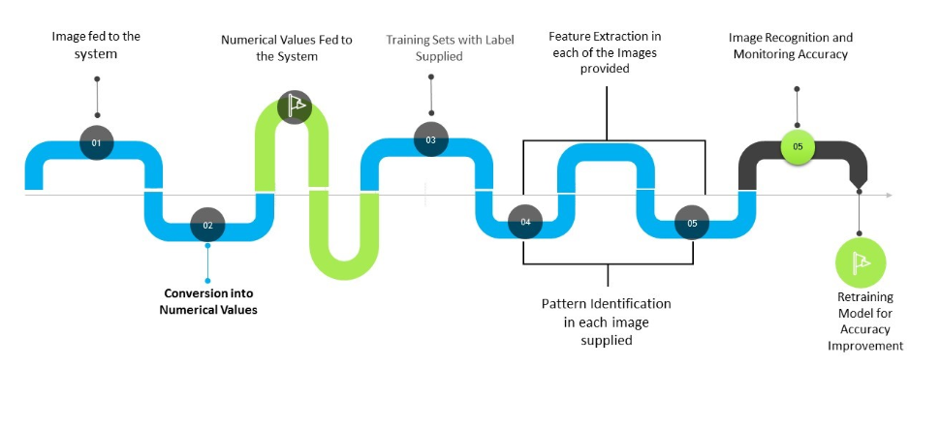** Fig: 1.1 Image Recognition Road map

**How image recognition works: algorithms and technologies?**

Before diving into how image recognition works, let's look at the four primary purposes image recognition solves: detection, classification, tagging, and segmentation.

****Classification****

Artificial neural networks identify objects in the image and assign them one of the predefined groups or classifications.

****Detection****

The process of classification and localization of an object is called object detection. Once the object's location is found, a bounding box with the corresponding accuracy is put around it. Depending on the complexity of the object, techniques like [bounding box annotation](https://www.v7labs.com/blog/bounding-box-annotation), [semantic segmentation](https://www.v7labs.com/blog/semantic-segmentation-guide), and key point annotation are used for detection.

****Tagging****

Tagging is similar to classification but aims for better accuracy. It tries to identify multiple objects in an image. Therefore, an image can have one or more tags. Returning to the example of the image of a road, it can have tags like 'vehicles,' 'trees,' 'human,' etc.

****Segmentation****

[Instance segmentation](https://www.v7labs.com/blog/instance-segmentation-guide) is the detection task that attempts to locate objects in an image to the nearest pixel. Instead of aligning boxes around the objects, an algorithm identifies all pixels that belong to each class. Image segmentation is widely used in medical imaging to detect and label image pixels where precision is very important.

**1. Data collection**

To achieve image recognition, machine vision artificial intelligence models are fed with pre-labeled data to teach them to recognize images they’ve never seen before.

Some of the massive publicly available databases include Pascal VOC and ImageNet. They contain millions of labeled images describing the objects present in the pictures—everything from sports and pizzas to mountains and cats.

**Tulasi**

**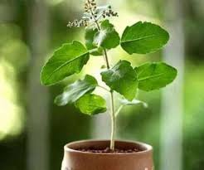 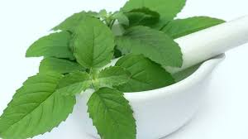 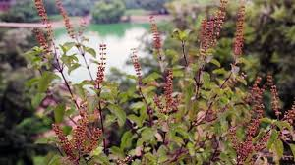 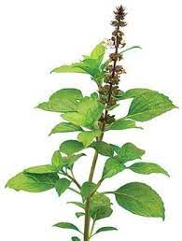**

**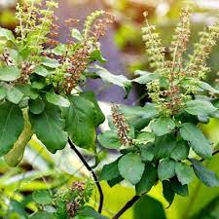 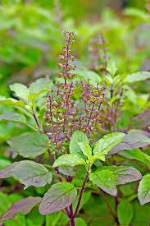 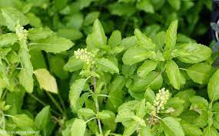 **

Fig: 1.2 Collected Tulasi Dataset

**Vasaka**

**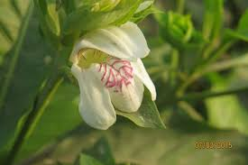 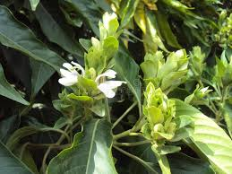 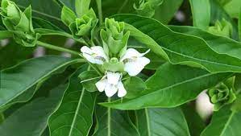 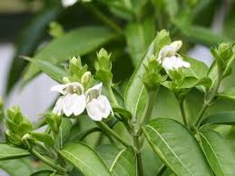**

** 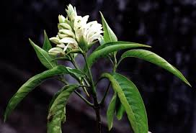 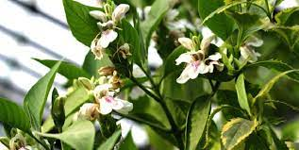**

Fig: 1.3 Collected Vasaka Dataset

**Neem**

**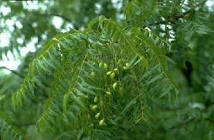 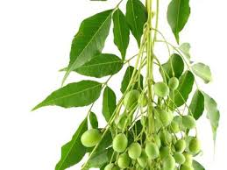 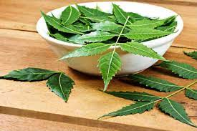 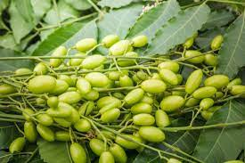**

**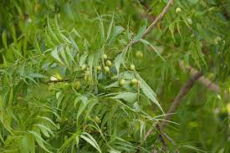 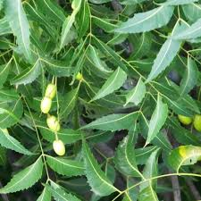 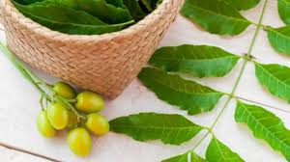 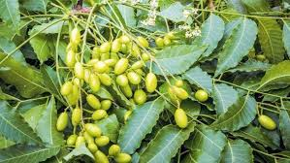**

Fig: 1.4 Collected Neem Dataset

**Cardamom**

**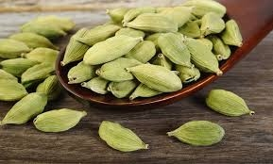 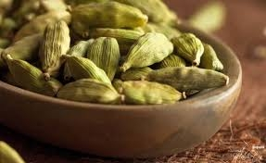 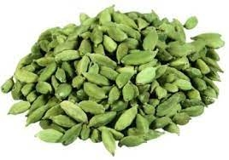 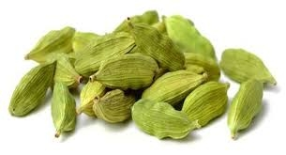**

**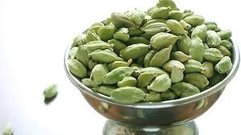 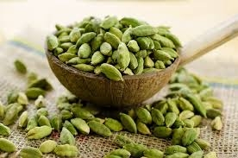 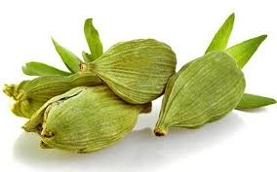 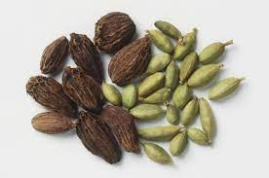**

Fig: 1.5 Collected Cardamom Dataset

**Bhringaraj**

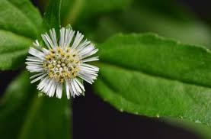 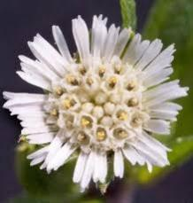 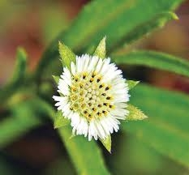 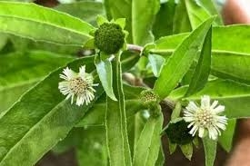

Fig: 1.6 Collected Bhringaraj Dataset

**Ashwagandha**

**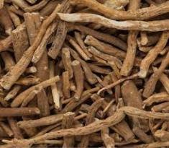 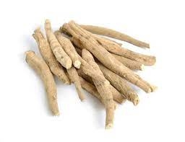  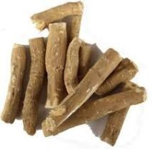 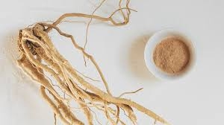**

**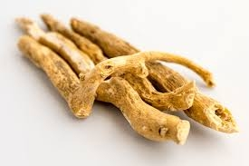 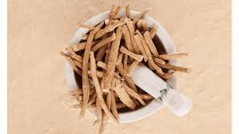 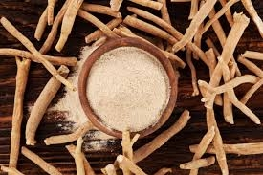 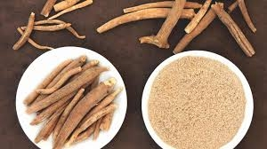**

Fig: 1.7 Collected Ashwagandha Dataset

****Variation in the viewpoint of the image.****The images can be aligned at different angles or vary in dimension, which can lead to inaccurate prediction of the machine learning model. The system fails to understand the effect of changing the alignment and viewport of the image.

****Deformation.**** Generally, training data gives a biased perception that a particular object can only have a specific shape.

****Occlusion.**** Some objects may obstruct the full view of an image and result in partial information being fed to the system. The neural network should acknowledge these variations as a part of the training process.

****Inter-class variations.**** Some objects might vary in shape, size, and structure but can still belong to the same class. Having all the varied data points is crucial for better [image processing](https://www.v7labs.com/blog/image-processing-guide).

### **2. Pre-processing of the image data**

Once the dataset is ready, there are several things to be done to maximize its efficiency for model training.

#### **Data annotation**

#### The objects in the image that serve as the regions of interest have to labeled (or annotated) to be detected by the computer vision system. In other words, labels have to be applied to those frames or images.

Annotations for segmentation tasks can be performed easily and precisely by making use of V7 annotation tools, specifically the polygon annotation tool and the [auto-annotate tool](https://www.v7labs.com/automated-annotation). A label once assigned is remembered by the software in the subsequent frames.

#### **Representation of image**

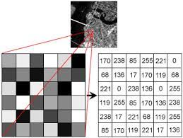

Fig: 1.8 Pixel representation of digital image

A digital image has a matrix representation that illustrates the intensity of pixels. The information fed to the image recognition models is the location and intensity of the pixels of the image. This information helps the image recognition work by finding the patterns in the subsequent images supplied to it as a part of the learning process.

### **3. Model architecture and training process**

Due to their unique work principle, convolutional neural networks (CNN) yield the best results with deep learning image recognition.

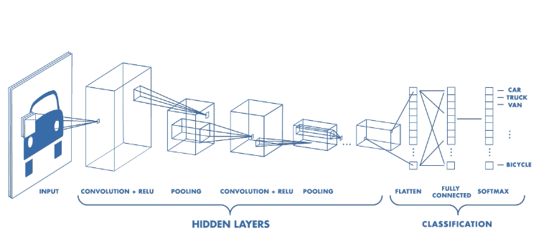

Fig: 1.9 Working of convolutional neural networks in image recognition

The complete pixel matrix is not fed to the CNN directly as it would be hard for the model to extract features and detect patterns from a high-dimensional sparse matrix. Instead, the complete image is divided into small sections called feature maps using filters or kernels.

### **4.Traditional machine learning algorithms for image recognition**

### Before the development of parallel processing and extensive computing capabilities required for training deep learning models, traditional machine learning models had set standards for image processing.

Let us quickly walk through some of the most learned machine learning models:

****Support Vector Machines****

SVMs describe features by making histograms of images. They use a sliding detection window technique by moving around the image. The algorithm then takes the test picture and compares the trained histogram values with the ones of various parts of the picture to check for close matches.

****Bag of Features****

Bag of Features models like Scale Invariant Feature Transformation (SIFT) does pixel-by-pixel matching between a sample image and its reference image. The trained model then tries to pixel match the features from the image set to various parts of the target image to see if matches are found.

Some other machine learning models widely used in computer vision include:

* Regression Algorithms
* Instance-based Algorithms
* Regularization Algorithms
* Decision Tree Algorithms
* Bayesian Algorithms
* Clustering Algorithms

### **5. Popular deep learning models for image recognition**

Here’s a quick look into some of the most popular deep learning models recently:

#### YOLO (You Only Look Once)

This object detection algorithm uses a confidence score and annotates multiple objects via bounding boxes within each grid box. [YOLO](https://www.v7labs.com/blog/yolo-object-detection), as the name suggests, processes a frame only once using a fixed grid size and then determines whether a grid box contains an image or not.

**1.5 PROBLEM STATEMENT:**

The problem addressed is the lack of a streamlined healthcare management system. This Android app aims to bridge the gap by enabling admins to manage professionals, users to access nearby healthcare providers, schedule appointments, and utilize image recognition for Ayurveda hints, thereby enhancing overall healthcare efficiency.

**1.6 OBJECTIVE OF THE PROJECT**

The objective is to enhance accessibility, convenience, and communication in healthcare, ensuring users receive personalized and efficient services. The incorporation of image recognition adds an innovative dimension, furthering the app's commitment to holistic healthcare solutions.

**1.7 SCOPE**

The scope of the Android application encompasses the seamless management of healthcare services, allowing administrators to efficiently add and monitor doctors and yoga masters. Users can easily find nearby healthcare professionals, schedule appointments, and utilize image recognition for Ayurveda hints.

**1.8 PROJECT INTRODUCTION**

Designed to cater to both users and administrators, this comprehensive platform redefines the way we approach healthcare services. Seamlessly integrating advanced features and user-friendly interfaces, our app empowers administrators with privileged access to add doctors and yoga masters, view appointments, and manage user profiles. This centralized control ensures efficient healthcare administration, fostering streamlined communication among administrators, doctors, and users. For users, the journey begins with a simple registration process, unlocking a world of possibilities. The app offers a personalized experience, allowing users to explore nearby doctors and yoga masters, access invaluable Ayurveda hints, and conveniently schedule appointments. What sets this application apart is its unique feature enabling users to upload Ayurveda-related pictures. The embedded image recognition technology provides insightful hints, enhancing the overall user experience and promoting a deeper understanding of holistic wellness practices. Doctors, too, benefit from a secure login portal, providing them with a dedicated space to manage appointments, update statuses, and monitor costs. This collaborative platform fosters a sense of community and connectivity, ensuring that healthcare services are not just efficient but also tailored to individual needs.

**1.9 PROCESS:**

In this project, first we clean the dataset to check whether any mislead data and null values are present. After that we split the data into train and test datasets. The training data is trained by using respective algorithms and then we predict the outcomes of the test data and we cross-validate with the train data to know whether we got the correct results. The accuracy will be calculated and plotted as bar graph with respect to the algorithms which we taken.

**1.10 FEATURES:**

* Effortless addition and oversight of doctors and yoga masters by administrators.
* Streamlined appointment scheduling for users.
* Proximity-based searches for healthcare providers.
* Innovative image recognition for Ayurveda insights.
* User-friendly experience with easy appointment scheduling and personalized hints.

**1.11 EXISTING SYSTEM:**

The current healthcare system lacks a centralized platform, resulting in inefficiencies such as cumbersome appointment scheduling, limited accessibility to healthcare providers, and a lack of integration between administrators, doctors, and users. User experiences are hindered by the absence of a streamlined process for finding nearby professionals and managing appointments.

**Disadvantages**

* Lack of integration between administrators, doctors, and users.
* Inefficient user experiences.
* Absence of features like image recognition for Ayurveda hints.
* Disjointed healthcare processes.

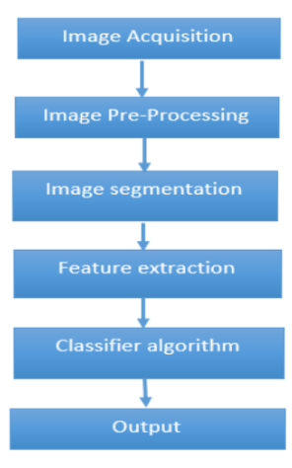

Fig: 1.10 Steps for Image Recognition

**1.12 K-NEAREST NEIGHBOR ALGORITHM:**

The **K-Nearest Neighbors (KNN) algorithm** is a supervised machine learning method employed to tackle classification and regression problems. 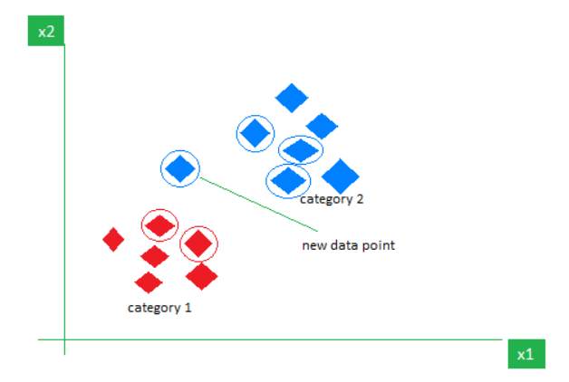

Fig: 1.11 KNN Algorithm Working Visualization

## **Working of KNN algorithm**

Thе K-Nearest Neighbors (KNN) algorithm operates on the principle of similarity, where it predicts the label or value of a new data point by considering the labels or values of its K nearest neighbors in the training dataset.

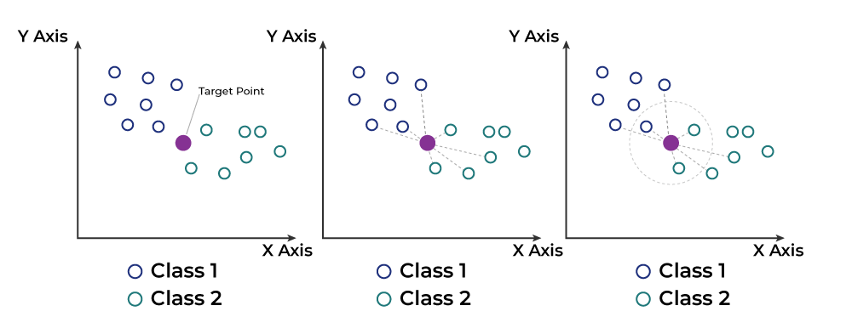 Fig: 1.12 KNN Algorithm Working

### Step 1: Selecting the optimal value of K

### Step 2: Calculating distance

### Step 3: Finding Nearest Neighbors

### Step 4: Voting for Classification or Taking Average for Regression

### **Advantages of the KNN Algorithm**

1. **Easy to implement** as the complexity of the algorithm is not that high.
2. **Adapts Easily** – As per the working of the KNN algorithm it stores all the data in memory storage and hence whenever a new example or data point is added then the algorithm adjusts itself as per that new example and has its contribution to the future predictions as well.
3. **Few Hyperparameters** – The only parameters which are required in the training of a KNN algorithm are the value of k and the choice of the distance metric which we would like to choose from our evaluation metric.

**1.13 CONVOLUTIONAL NEURAL NETWORKS**

A **Convolutional Neural Network (CNN)** is a type of Deep Learning neural network architecture commonly used in Computer Vision. Computer vision is a field of Artificial Intelligence that enables a computer to understand and interpret the image or visual data.

In a regular Neural Network there are three types of layers:

1. **Input Layers:** It’s the layer in which we give input to our model. The number of neurons in this layer is equal to the total number of features in our data (number of pixels in the case of an image).
2. **Hidden Layer:** The input from the Input layer is then fed into the hidden layer. There can be many hidden layers depending on our model and data size. Each hidden layer can have different numbers of neurons which are generally greater than the number of features. The output from each layer is computed by matrix multiplication of the output of the previous layer with learnable weights of that layer and then by the addition of learnable biases followed by activation function which makes the network nonlinear.
3. **Output Layer:** The output from the hidden layer is then fed into a logistic function like sigmoid or softmax which converts the output of each class into the probability score of each class. The data is fed into the model and output from each layer is obtained from the above step is called [feedforward](https://www.geeksforgeeks.org/understanding-multi-layer-feed-forward-networks/), we then calculate the error using an error function, some common error functions are cross-entropy, square loss error, etc. The error function measures how well the network is performing. After that, we backpropagate into the model by calculating the derivatives. This step is called [Backpropagation](https://www.geeksforgeeks.org/backpropagation-in-data-mining/) which basically is used to minimize the loss. Convolutional Neural Network (CNN) is the extended version of [artificial neural networks (ANN)](https://www.geeksforgeeks.org/artificial-neural-networks-and-its-applications/) which is predominantly used to extract the feature from the grid-like matrix dataset. For example visual datasets like images or videos where data patterns play an extensive role.

**CNN architecture**

Convolutional Neural Network consists of multiple layers like the input layer, Convolutional layer, Pooling layer, and fully connected layers. The Convolutional layer applies filters to the input image to extract features, the Pooling layer downsamples the image to reduce computation, and the fully connected layer makes the final prediction. The network learns the optimal filters through backpropagation and gradient descent.

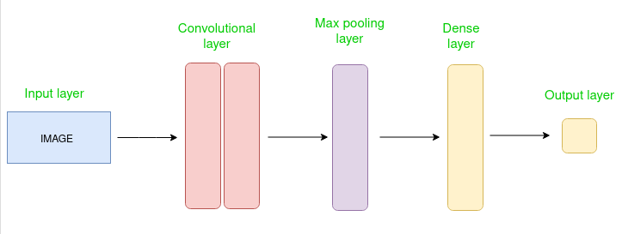

Fig: 1.13 CNN Architecture

**How Convolutional Layers works**

Convolution Neural Networks or covnets are neural networks that share their parameters. Imagine you have an image. It can be represented as a cuboid having its length, width (dimension of the image), and height (i.e the channel as images generally have red, green, and blue channels).

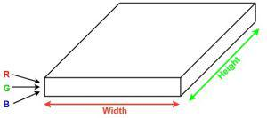

Fig: 1.14 Dimensions of example image

Now imagine taking a small patch of this image and running a small neural network, called a filter or kernel on it, with say, K outputs and representing them vertically. Now slide that neural network across the whole image, as a result, we will get another image with different widths, heights, and depths. Instead of just R, G, and B channels now we have more channels but lesser width and height. This operation is called **Convolution**. If the patch size is the same as that of the image it will be a regular neural network. Because of this small patch, we have fewer weights.

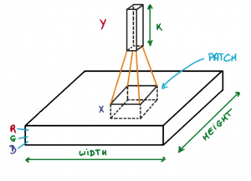

Fig: 1.15 Process of Convolution

Now let’s talk about a bit of mathematics that is involved in the whole convolution process.

1. Convolution layers consist of a set of learnable filters (or kernels) having small widths and heights and the same depth as that of input volume (3 if the input layer is image input).
2. For example, if we have to run convolution on an image with dimensions 34x34x3. The possible size of filters can be axax3, where ‘a’ can be anything like 3, 5, or 7 but smaller as compared to the image dimension.
3. During the forward pass, we slide each filter across the whole input volume step by step where each step is called [stride](https://www.geeksforgeeks.org/ml-introduction-to-strided-convolutions/) (which can have a value of 2, 3, or even 4 for high-dimensional images) and compute the dot product between the kernel weights and patch from input volume.
4. As we slide our filters we’ll get a 2-D output for each filter and we’ll stack them together as a result, we’ll get output volume having a depth equal to the number of filters. The network will learn all the filters.

### **Layers used to build ConvNets**

A complete Convolution Neural Networks architecture is also known as covnets. A covnets is a sequence of layers, and every layer transforms one volume to another through a differentiable function.   
**Types of layers**  
Let’s take an example by running a covnets on of image of dimension 32 x 32 x 3.

1. **Input Layers:** It’s the layer in which we give input to our model. In CNN, Generally, the input will be an image or a sequence of images. This layer holds the raw input of the image with width 32, height 32, and depth 3.
2. **Convolutional Layers:**This is the layer, which is used to extract the feature from the input dataset. It applies a set of learnable filters known as the kernels to the input images. The filters/kernels are smaller matrices usually 2×2, 3×3, or 5×5 shape. it slides over the input image data and computes the dot product between kernel weight and the corresponding input image patch. The output of this layer is referred ad feature maps. Suppose we use a total of 12 filters for this layer we’ll get an output volume of dimension 32 x 32 x 12.
3. **[Activation Layer:](https://www.geeksforgeeks.org/activation-functions-neural-networks/)**By adding an activation function to the output of the preceding layer, activation layers add nonlinearity to the network. it will apply an element-wise activation function to the output of the convolution layer. Some common activation functions are **RELU**: max(0, x),  **Tanh**, **Leaky RELU**, etc. The volume remains unchanged hence output volume will have dimensions 32 x 32 x 12.
4. **[Pooling layer:](https://www.geeksforgeeks.org/cnn-introduction-to-pooling-layer/)**This layer is periodically inserted in the covnets and its main function is to reduce the size of volume which makes the computation fast reduces memory and also prevents overfitting. Two common types of pooling layers are **max pooling** and **average pooling**. If we use a max pool with 2 x 2 filters and stride 2, the resultant volume will be of dimension 16x16x12.
5. **Fully Connected Layers:**It takes the input from the previous layer and computes the final classification or regression task.
6. **Output Layer:** The output from the fully connected layers is then fed into a logistic function for classification tasks like sigmoid or softmax which converts the output of each class into the probability score of each class.

**CHAPTER 2**

**REVIEW OF LIERATURE**

**2.1 Aastha Zade, Gauri Chaudhari, Khyati Raghvani, Sakshi Bodke, Prof.G.R.Shinde, Ayurvedacharya App, 2022**

In Ayurvedic Medicine is a system of traditional medicine native to Indians and is a form of alternative medicine. Ayurveda makes the use of plants-based medicine and treatments. Ayurvedic therapy is taken by controlling food habits, taking necessary foods for curing the disease and controlling daily life style. Ayurvedic Remedies are now widely accepted throughout the world. Most of the ingredients of any Ayurvedic Cures can be found at home easily. So, cures are not very costly and can be done easily.

**2.2 Nagashree m annigeri, pramod sunagar,"ayurveda upachara-an android app",2018**

Ayurvedic Medicine is a system of traditional medicine native to Indians and is a form of alternative medicine. Ayurveda makes the use of plants-based medicine and treatments. Ayurvedic therapy is taken by controlling food habits, taking necessary foods for curing the disease and controlling daily life style. Ayurvedic Remedies are now widely accepted throughout the world. Most of the ingredients of any Ayurvedic Cure can be found in home easily.

**2.3 D.B. Anantha Narayana and Sharanbasappa Durg,"Ayurveda: (W)here is the evidence",2021**

Ayurveda lacks scientific evidence. By scientific evidence, it is commonly referred to results of human clinical trials undertaken adoring those applied to pharmaceuticals, involving randomized controlled trials (RCT), either a placebo or active controlled. This paper explores the actual situation related to practice of Ayurveda, use of medicines, application of therapies, and the individual dravyas (ingredients). It gives few examples and availability of large body of scientific data in this area. The study, however, does not discuss the reasons and problems of conducting RCTs.

**2.4 A.D.A.D.S. Jayalath; P.V.D. Nadeeshan; T.G.A.G.D Amarawansh; H.P Jayasuriya; D. P. Nawinna, Ayurvedic Knowledge Sharing Platform with Sinhala Virtual Assistant,2019**

In this Ayurveda methods identification of indigenous plants to predict the medicines is very important and must do very carefully. Generally main components that we use to identify a plant are leaf, flower, trunk and root etc. Among these features, we use images of leaves and flowers. To do this we are using deep learning-based CNN approaches. Another useful feature of this system is it provides relevant information of Ayurveda doctors. So, users can find doctors according to their needs and they are able to rate and give recommendations for the doctors. That will be help others to find doctors more easily and efficiently without any doubt.

**2.5 Ayan Banerjee,Sandeep K. S. Gupta,"Analysis of Smart Mobile Applications for Healthcareunder Dynamic Context Changes",2014**

This paper proposes a novel technique to analyze SMDCS taking into account the dynamic changes in the context and the constant interaction of the computing systems with the physical environment. To show the usage of the technique, Ayushman pervasive health monitoring system is considered as an example SMDCS. Analytical results show that practices considered healthy for a person such as mobility may not be beneficial when an SMDCS is controlling health.

**CHAPTER 3**

**PROPOSED SOLUTION**

**3.1 OVERVIEW:**

Revolutionize healthcare with our Android app, a groundbreaking management system connecting users, administrators, doctors, and yoga masters. Admins effortlessly add healthcare professionals and oversee appointments, while users access nearby experts, Ayurveda insights, and appointment scheduling. The app's image recognition feature enhances Ayurveda experiences, and doctors’ benefit from a secure portal for managing appointments. With a focus on user-friendly design, this app transforms healthcare into a seamless, holistic journey for all.

**3.2 PROPOSED SYSTEM:**

The proposed Android application revolutionizes healthcare management by offering a centralized platform. Admins can effortlessly add and oversee doctors and yoga masters. Users benefit from streamlined appointment scheduling, proximity-based searches for healthcare providers, and an innovative image recognition feature providing Ayurveda insights. The app ensures a user-friendly experience, allowing patients to easily find nearby professionals, schedule appointments, and upload images for personalized hints. For doctors, it provides a secure platform to manage appointments efficiently. The proposed system aims to create a cohesive healthcare ecosystem, enhancing accessibility, communication, and overall user satisfaction in the healthcare journey.

**Advantages of Proposed System**

* Effortless addition and oversight of doctors and yoga masters by administrators.
* Streamlined appointment scheduling for users.
* Proximity-based searches for healthcare providers.
* Innovative image recognition for Ayurveda insights.
* User-friendly experience with easy appointment scheduling and personalized hints.

Secure platform for doctors to efficiently manage appointments.

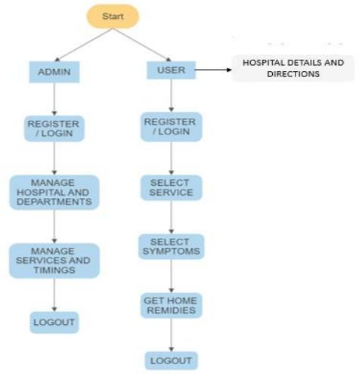

Fig: 3.1 System Flowchart

**3.3 FUNCTIONAL REQUIREMENTS FOR PROPOSED SYSTEM**

**1.User Registration and Authentication :** Users should be able to create accounts and log in securely.User roles (e.g., patient, healthcare practitioner) may be defined.

**2.Hospital Search and Location Services** **:** Users can search for Ayush hospitals by location, name, or specialization. The application should display hospital locations on a map using Google Maps API.

**3. Hospital Details :**Users can view detailed information about each hospital, including contact details, services offered, and address.

**4. User Reviews and Ratings :**Users can read and submit reviews and ratings for hospitals and services. Reviews should include ratings for factors like service quality, cleanliness, and staff behavior.

**5. Filter and Sorting Options :**Users can filter and sort search results based on criteria such as distance, ratings, and services offered.

**6. Notifications :** Users may receive notifications about hospital updates, new services, or appointment reminders.

**7. Appointment Booking :** Users should be able to request appointments with healthcare professionals or services offered by the hospitals.

**8. Multi-language Support :** The application should be accessible in multiple languages to cater to a diverse user base.

**9. User Education and Resources :** Provide educational resources on Ayush treatments, wellness, and health tips.

**3.4 PROPOSED SYSTEM ARCHITECTURE**

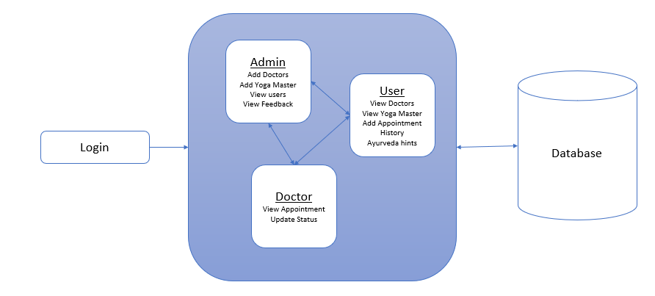

Fig: 3.2 Proposed System Architecture

**3.5 SYSTEM DESIGN**

**INPUT DESIGN**

The input design is the link between the information system and the user. It comprises the developing specification and procedures for data preparation and those steps are necessary to put transaction data in to a usable form for processing can be achieved by inspecting the computer to read data from a written or printed document or it can occur by having people keying the data directly into the system. The design of input focuses on controlling the amount of input required, controlling the errors, avoiding delay, avoiding extra steps and keeping the process simple. The input is designed in such a way so that it provides security and ease of use with retaining the privacy.

**OUTPUT DESIGN**

A quality output is one, which meets the requirements of the end user and presents the

information clearly. In any system results of processing are communicated to the users and to other system through outputs. In output design it is determined how the information is to be displaced for immediate need and also the hard copy output. It is the most important and direct source information to the user. Efficient and intelligent output design improves the system’s relationship to help user decision-making.

**3.6 UML DIAGRAMS**

UML stands for Unified Modelling Language. UML is a standardized general-purpose modelling language in the field of object-oriented software engineering. The standard is managed, and was created by, the Object Management Group.

**USE CASE DIAGRAM:**

A use case diagram in the Unified Modeling Language (UML) is a type of behavioral diagram defined by and created from a Use-case analysis. Its purpose is to present a graphical overview of the functionality provided by a system in terms of actors, their goals (represented as use cases), and any dependencies between those use cases.

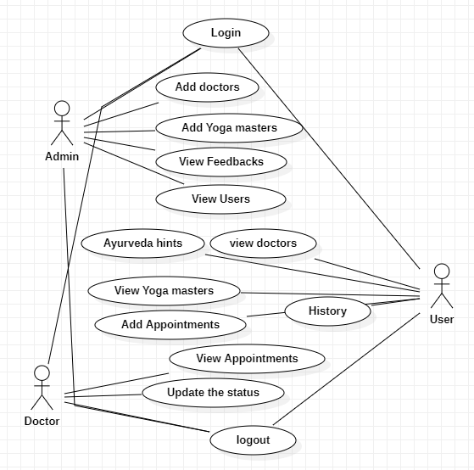

Fig: 3.3 Usecase Diagram

**CLASS DIAGRAM:**

In software engineering, a class diagram in the Unified Modelling Language (UML) is a type of static structure diagram that describes the structure of a system by showing the system's classes, their attributes, operations (or methods), and the relationships among the classes. It explains which class contains information.

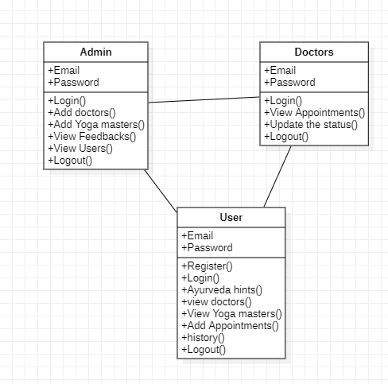

Fig: 3.4 Class Diagram

**SEQUENCE DIAGRAM:**

A sequence diagram in Unified Modelling Language (UML) is a kind of interaction diagram that shows how processes operate with one another and in what order. It is a construct of a Message Sequence Chart. Sequence diagrams are sometimes called event diagrams, event scenarios, and timing diagrams.

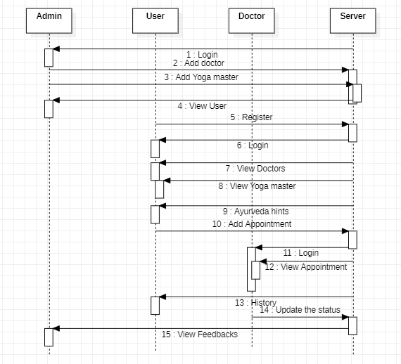

Fig: 3.5 Sequence Diagram

**COLLABORATION DIAGRAM:**

In collaboration diagram the method call sequence is indicated by some numbering technique as shown below. The number indicates how the methods are called one after another. We have taken the same order management system to describe the collaboration diagram. The method calls are similar to that of a sequence diagram. But the difference is that the sequence diagram does not describe the object organization whereas the collaboration diagram shows the object organization.

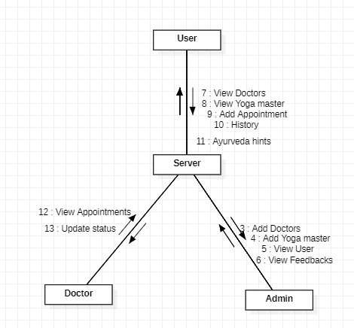

Fig: 3.6 Collaboration Diagram

**ACTIVITY DIAGRAM:**

Activity diagrams are graphical representations of workflows of stepwise activities and actions with support for choice, iteration and concurrency. In the Unified Modelling Language, activity diagrams can be used to describe the business and operational step-by-step workflows of components in a system. An activity diagram shows the overall flow of control.

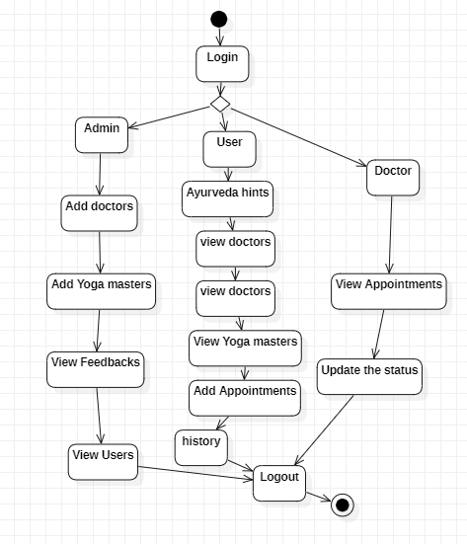

Fig: 3.7 Activity Diagram

**COMPONENT DIAGRAM:**

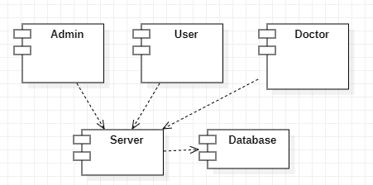

Fig: 3.8 Component Diagram

In UML, component diagrams show the structure of the software system, which describes the software components, their interfaces and their dependencies

**DEPLOYMENT DIAGRAM:**

Deployment diagrams show the relationships between the software and hardware components in the system and the physical distribution of the processing.

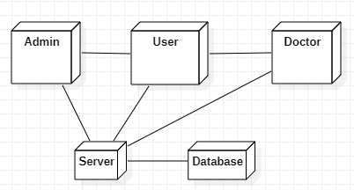

Fig: 3.9 Deployment Diagram

**ER Diagram:**

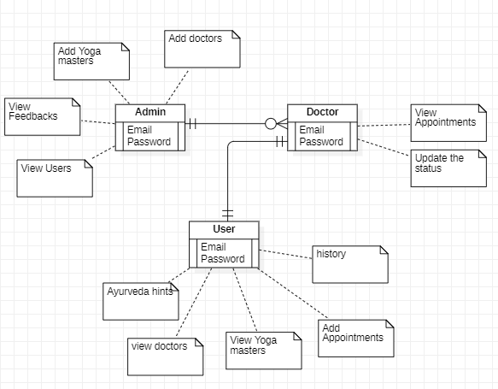

Fig: 3.10 ER Diagram

**Data Flow Diagram:**

A data flow diagram (DFD) maps out the flow of information for any process or system. It uses defined symbols like rectangles, circles and arrows, plus short text labels, to show data inputs, outputs, storage points and the routes between each destination.

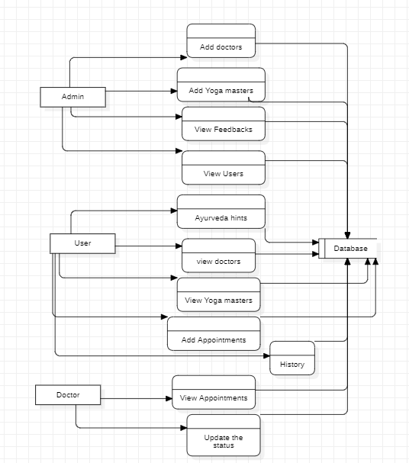

Fig: 3.11 Data Flow Diagram

**3.7 PROCESS**

**SOFTWARE DEVELOPMENT LIFE CYCLE**

Agile model is the combination of iterative and incremental process models. Steps involve in agile SDLC models are:

* Requirement gathering
* Requirement Analysis
* Design Coding
* Unit testing
* Acceptance testing

**Principles of Agile model:**

* To establish close contact with the customer during development and to gain a clear understanding of various requirements, each Agile project usually includes a customer representative on the team. At the end of each iteration stakeholders and the customer representative review, the progress made and re-evaluate the requirements.

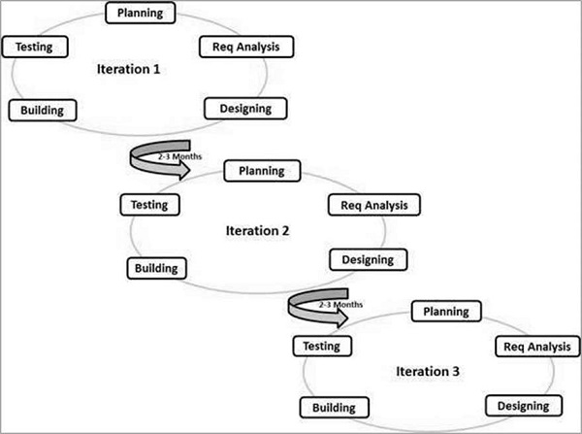 Fig: 3.12 Agile Methodology Life Cycle

**CHAPTER 4**

**IMPLEMENTATION**

**4.1 SOFTWARE INSTALLATION**

**4.1.1 Software Installation of JDK kit**

This Java Development Kit (JDK) allows you to code and run Java programs. It's possible that you install multiple JDK versions on the same PC. But it’s recommended that you install only latest version.

**How to install Java for Windows**

## Following are the steps for JDK 8 free download for 32 bit or JDK 8 download 64 bit and installation

**Step 1)** Go to [link](https://www.oracle.com/java/technologies/javase-downloads.html) Click on JDK Download for Java

**Step 2)** Next,

1. Accept License Agreement
2. Download Java 8 JDK for your version 32 bit or JDK 8 download for windows 10 64 bit.

**Step 3)** when you click on the Installation link the popup will be open. Click on I reviewed and accept the Oracle Technology Network License Agreement for Oracle Java SE and you will be redirected to the login page. If you don't have an oracle account you can easily sign up by adding basics details of yours.

**Step 4)** once the Java JDK 8 download is complete, run the exe for install JDK. Click Next

**Step 5)** Select the PATH to install Java in Windows and click next.

**Step 6)** Once you install Java in windows, click Close

**How to set Environment Variables in Java: Path and Class path**

The PATH variable gives the location of executable like javac, java etc. It is possible to run a program without specifying the PATH but you will need to give full path of executable like **C:\Program Files\Java\jdk-13.0.1\bin\javac A.java** instead of simple **javac A.java**

The CLASSPATH variable gives location of the Library Files.

Let's look into the steps to set the PATH and CLASSPATH

**Step 1)** Right Click on the My Computer and Select the properties

**Step 2)** Click on advanced system settings

**Step 3)** Click on Environment Variables

**Step 4)** Click on new Button of User variables

**Step 5)** Type PATH in the Variable name.

**Step 6)** Copy the path of bin folder which is installed in JDK folder.

**Step 7)** Paste Path of bin folder in Variable value and click on OK Button.

**Step 8)**You can follow a similar process to set CLASSPATH.

**Step 9)** Click on OK button

**Step 10)** Go to command prompt and type java commands.

If you see a screen like below, Java is installed.

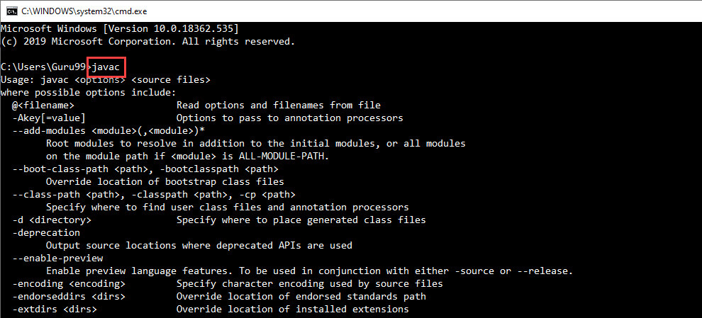

Fig: 4.1 Java Installation Screen

**4.1.2 Android Studio IDE and SDK Installation**

Installing Android software is probably the most challenging part of this project. It takes times - from 30 minutes to *n* hours to forever - depending on your luck, your programming knowledge, and your PC. You probably need a fairly decent PC (with 8GB RAM) and 10GB of free disk space to run the Android emulator!!! Running on "actual" Android phone/tablet requires much lesser resources.

##### **Step 0: Pre-Installation Check List**

1. Before installing Android SDK, you need to install Java Development Kit (JDK). Read "[How to install JDK](https://www3.ntu.edu.sg/home/ehchua/programming/howto/JDK_HowTo.html)". Ensure that your JDK is at or above 1.8. You can check your JDK version with command "javac -version".
2. Uninstall older version(s) of "Android Studio" and "Android SDK", if any.
3. The installation and many operations take a LONG time to complete. Do NOT stare at your screen or at the ceiling. Browse through the "Android Developers" @ [https://developer.android.com](https://developer.android.com/index.html). For developers, check out the "Developer Guides".
4. We need to install two huge packages:
5. Android Studio (IDE) (about 1 GB), which is an Integrated Development Environment (IDE) based on IntelliJ (a popular Java IDE); and
6. Android SDK (Software Development Kit) (about 5 GB) for developing and testing Android apps.

##### **Step 1: Install "Android Studio IDE"**

Reference: "Install Android Studio" @ <https://developer.android.com/studio/install>.

##### (For Windows)

1. Check that environment variable JAVA\_HOME is set to the JDK installation directory via command "set JAVA\_HOME". Otherwise, Follow the steps [HERE](https://www3.ntu.edu.sg/home/ehchua/programming/howto/JDK_HowTo.html" \l "Set-JAVA_HOME).
2. Check the system requirements for Android Studio/SDK @ [https://developer.android.com/studio#Requirements](https://developer.android.com/studio" \l "Requirements) e.g., For Windows 10, recommended 8GB of RAM, 4GB of disk space, and 1280x800 minimum screen resolution.
3. Go to "Android Studio" @ <https://developer.android.com/studio> ⇒ Click "Download Android Studio 3.6.x for Windows 64-bit (749MB)", e.g., "android-studio-ide-192.xxxxxxx-windows.exe".
4. Run the downloaded installer ⇒ You may watch a short video @ <https://developer.android.com/studio/install>.
   1. In "Choose Components", select "Android Studio" and "Android Virtual Device".
   2. In "Configuration Settings Install Location", accept the default "C:\Program Files\Android\Android Studio".
   3. In "Choose Start Menu Folder", accept the default ⇒ Install.
   4. Launch Android Studio. Continue to the next Step.

by default, the "Android Studio IDE" will be installed in "C:\Program Files\Android\Android Studio", and the "Android SDK" in "c:\Users\username\AppData\Local\Android\Sdk".

Notes: You can also use the ZIP version: Download the Windows 64-bit ZIP version (about 1.5GB) ⇒ UNZIP into a folder of your choice ⇒ Run "bin\studio64.exe" to launch the Android Studio ⇒ It will enter the "setup" for the first launch ⇒ "Do not Import Settings" ⇒ In "Welcome", click "Next" ⇒ In "Install Type", choose "Custom" (so that you can see what is going on) ⇒ In "Select Default JDK Location", use default ⇒ In "Select UI Theme", choose one that you like ⇒ In "SDK Components Setup", select "Android Virtual Device (1.05GB) ⇒ Take note of the "Android SDK Location" with default of "C:\Users\username\AppData\Local\Android\Sdk" ⇒ In "Emulator Settings", use default ⇒ In "Verify Settings", check the settings and choose "Finish" ⇒ In "Download Components", click "Details" and check that nothing fails ⇒ Wait ⇒ Wait ⇒ Wait.

##### **Step 2: Installing Android SDK**

##### This step takes a long time as you need to download about 3GB of zip data, and expand to 5 GB of disk data, even for the minimum configuration.

Note: You can actually copy the SDK from another computer with the same OS.

##### (For Windows and macOS)

1. Launch Android Studio ⇒ It will run the "setup" wizard for the first launch.
   1. Choose "do not import previous settings".
   2. In "Welcome", choose "next".
   3. In "Install Type", choose "Standard" (default).
   4. In "Select UI Theme", choose one that you like (or default).
   5. In "SDK Components Setup", make sure that "Android Virtual Device" is selected and take note of the SDK directory (by default @ c:\Users\*username*\AppData\Local\Android\Sdk for Windows, "~/Library/Android/sdk" for macOS) ⇒ Finish ⇒ Wait ⇒ Wait ⇒ Wait ⇒ Wait ⇒ Wait ⇒ Wait.
2. (For Windows) Use "File Explorer" to check the SDK installed directory. Take note that the "App Data" is a hidden directory. You need to choose "View" menu ⇒ Uncheck "Hidden Items" to see this directory.  
   (For macOS) Use "Finder" to check the SDK installed directory.
3. Also use "Android Studio" to check the SDK packages installed by selecting "Configure" (at the bottom of Android Studio) ⇒ "SDK Manager" ⇒ "Android SDK" (sidebar):
   1. Under "SDK Platforms" tab:
      * Android 10.0 (Q) (API Level 29)
   2. Under "SDK Tools" tab:
      * Android SDK Build Tools 30-rc1
      * Android Emulator (30.0.0)
      * Android SDK Platform-Tools (29.0.6)
      * Intel x86 Emulator Accelerator (HAXM installer) (7.5.6)

**STEPS FOR EXECUTING THE PROJECTS**

**Step 1:** Open Android Studio

**Step2:** Choose a virtual device or Physical device from the menu

**Step3:** Click on the project Run

**Step4:** View the application performance on virtual or Physical device.

**Software Environment**

Android is a software stack for mobile devices that includes an operating system, middleware and key applications. The Android SDK provides the tools and APIs necessary to begin developing applications Android platform using the Java programming language. Android has a large community of developers writing applications ("apps") that extend the functionality of the devices. There are currently over 250,000 apps available for Android.

**Features: -**

* **Application framework** enabling reuse and replacement of components
* **Dalvik virtual machine** optimized for mobile devices
* **Integrated browser** based on the open source Web Kit engine
* **Optimized graphics** powered by a custom 2D graphics library; 3D graphics based on the OpenGL ES 1.0 specification (hardware acceleration optional)
* **SQLite** for structured data storage
* **Media support** for common audio, video, and still image formats (MPEG4, H.264, MP3, AAC, AMR, JPG, PNG, GIF)
* **GSM Telephony** (hardware dependent)
* **Bluetooth, EDGE, 3G, and WIFI** (hardware dependent)
* **Camera, GPS, compass, and accelerometer** (hardware dependent)
* **Rich development environment** including a device emulator, tools for debugging, memory and performance profiling, and a plugin for the Eclipse IDE

**Libraries**

Android includes a set of C/C++ libraries used by various components of the Android system. These capabilities are exposed to developers through the Android application framework. Some of the core libraries are listed below:

* **System C library** - a BSD-derived implementation of the standard C system library (libc), tuned for embedded Linux-based devices
* **Media Libraries** - based on Packet Video’s Open CORE; the libraries support playback and recording of many popular audio and video formats, as well as static image files, including MPEG4, H.264, MP3, AAC, AMR, JPG, and PNG
* **Surface Manager** - manages access to the display subsystem and seamlessly composites 2D and 3D graphic layers from multiple applications
* **LibWebCore** - a modern web browser engine which powers both the Android browser and an embeddable web view
* **SGL** - the underlying 2D graphics engine
* **3D libraries** - an implementation based on OpenGL ES 1.0 APIs; the libraries use either hardware 3D acceleration (where available) or the included, highly optimized 3D software rasterizer
* **Free Type** - bitmap and vector font rendering
* **SQLite** - a powerful and lightweight relational database engine available to all applications

## **Android Runtime**

Android includes a set of core libraries that provides most of the functionality available in the core libraries of the Java programming language. Every Android application runs in its own process, with its own instance of the Dalvik virtual machine. Dalvik has been written so that a device can run multiple VMs efficiently. The Dalvik VM executes files in the Dalvik Executable (.dex) format which is optimized for minimal memory footprint. The VM is register-based, and runs classes compiled by a Java language compiler that have been transformed into the. dex format by the included "dx" tool. The Dalvik VM relies on the Linux kernel for underlying functionality such as threading and low-level memory management.

## **Linux Kernel**

Android relies on Linux version 2.6 for core system services such as security, memory management, process management, network stack, and driver model. The kernel also acts as an abstraction layer between the hardware and the rest of the software stack. The Linux kernel is an operating system kernel used by the Linux family of Unix-like operating systems. It is one of the most prominent examples of free and open source software. The Linux kernel is released under the GNU General Public License version 2 (GPLv2), (plus some firmware images with various licenses), and is developed by contributors worldwide. Day-to-day development takes place on the Linux kernel mailing list. The Linux kernel was initially conceived and created by Finnish computer science student Linus Torvalds in 1991. Linux rapidly accumulated developers and users who adapted code from other free software projects for use with the new operating system. The Linux kernel has received contributions from thousands of programmers Many Linux distributions have been released based upon the Linux kernel. The Linux kernel has extensive support for and runs on many virtual machine architectures both as the host operating system and as a guest operating system. The virtual machines usually emulate Intel x86 family of processors, though in a few cases PowerPC or ARM processors are also emulated.

## **Hardware running Android**

The main supported platform for Android is the ARM architecture.

The Android OS can be used as an operating system for cellphones, netbooks and tablets, including the Dell Streak, Samsung Galaxy Tab, TV and other devices.[68][69] The first commercially available phone to run the Android operating system was the HTC Dream, released on 22 October 2008.[70] In early 2010 Google collaborated with HTC to launch its flagship [71] Android device, the Nexus One. This was followed later in 2010 with the Samsung-made Nexus S.

The early feedback on developing applications for the Android platform was mixed. Issues cited include bugs, lack of documentation, inadequate QA infrastructure, and no public issue-tracking system. (Google announced an issue tracker on 18 January 2008.) In December 2007, Merge Lab mobile startup founder Adam Macbeth stated, "Functionality is not there, is poorly documented or just doesn't work... It's clearly not ready for prime time." Despite this, Android-targeted applications began to appear the week after the platform was announced. The first publicly available application was the Snake game The Android Dev Phone is a SIM-unlocked and hardware-unlocked device that is designed for advanced developers. While developers can use regular consumer, devices purchased at retail to test and use their applications, some developers may choose not to use a retail device, preferring an unlocked or no-contract device.

### **Android Operation System**

Android is an operating system based on Linux with a Java programming interface. It provides tools, e.g., a compiler, debugger and a device emulator as well as its own Java Virtual machine (Dalvik Virtual Machine - DVM). Android is created by the Open Handset Alliance which is led by Google.

Android uses a special virtual machine, e.g., the Dalvik Virtual Machine. Dalvik uses special bytecode. Therefore, you cannot run standard Java bytecode on Android. Android provides a tool "dx" which allows to convert Java Class files into "dex" (Dalvik Executable) files. Android applications are packed into an .apk (Android Package) file by the program "aapt" (Android Asset Packaging Tool) To simplify development Google provides the Android Development Tools (ADT) for Eclipse . The ADT performs automatically the conversion from class to dex files and creates the apk during deployment. Android supports 2-D and 3-D graphics using the OpenGL libraries and supports data storage in a SQLite database.

**Download the Android SDK**

If you're already using the Android SDK, you should update to the latest tools or platform using the Android SDK and AVD Manager, rather than downloading a new SDK starter package. See Adding SDK Components.

is now downloading. Follow the steps below to get started.

Here an overview of the steps you must follow to set up the Android SDK:

1. Prepare your development computer and ensure it meets the system requirements.
2. Install the SDK starter package from the table above. (If you're on Windows, download the installer for help with the initial setup.)
3. Install the ADT Plugin for Eclipse (if you'll be developing in Eclipse).
4. Add Android platforms and other components to your SDK.
5. Explore the contents of the Android SDK (optional).

**4.2 ANDROID ARCHITECTURE**

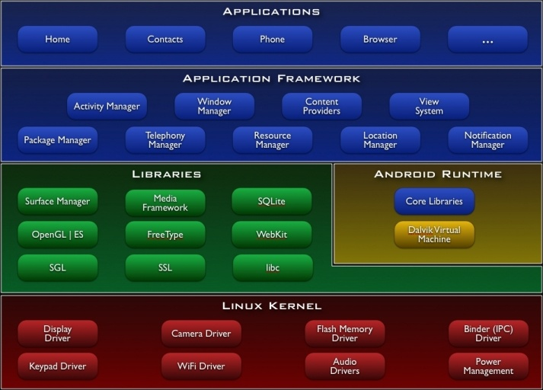

Fig: 4.2 Android Architecture

### **Important Android components**

An Android application consists out of the following parts:

1. Activity - Represents the presentation layer of an Android application, e.g., a screen which the user sees. An Android application can have several activities and it can be switched between them during runtime of the application.
2. Views - The User interface of an Activities is built with widgets classes which inherent from "android. view. View". The layout of the views is managed by "android. view. View Groups".
3. Services - perform background tasks without providing an UI. They can notify the user via the notification framework in Android.
4. Content Provider - provides data to applications, via a content provider your application can share data with other applications. Android contains a SQLite DB which can serve as data provider
5. Intents are asynchronous messages which allow the application to request functionality from other services or activities. An application can call directly a service or activity (explicit intent) or asked the Android system for registered services and applications for an intent (implicit intents). For example, the application could ask via an intent for a contact application. Application registers themself to an intent via an Intent Filter. Intents are a powerful concept as they allow to create loosely coupled applications.
6. Broadcast Receiver - receives system messages and implicit intents, can be used to react to changed conditions in the system. An application can register as a broadcast receiver for certain events and can be started if such an event occurs.
7. A Java Virtual Machine (JVM) enables a set of computer software programs and data structures to use a virtual machine model for the execution of other computer programs and scripts. The model used by a JVM accepts a form of computer intermediate language commonly referred to as Java bytecode. This language conceptually represents the instruction set of a stack-oriented, capability architecture. Sun Microsystems states there are over 4.5 billion JVM-enabled devices
8. A JVM can also execute bytecode compiled from programming languages other than Java. For example, Ada source code can be compiled to execute on a JVM. JVMs can also be released by other companies besides Oracle (the developer of Java) — JVMs using the "Java" trademark may be developed by other companies as long as they adhere to the JVM specification published by Oracle and to related contractual obligations.
9. Java was conceived with the concept of WORA: "write once, run anywhere". This is done using the Java Virtual Machine. The JVM is the environment in which java programs execute. It is software that is implemented on non-virtual hardware and on standard operating systems.
10. JVM is a crucial component of the Java platform, and because JVMs are available for many hardware and software platforms, Java can be both middleware and a platform in its own right, [clarification needed] hence the trademark write once, run anywhere. The use of the same bytecode for all platforms allows Java to be described as "compile once, run anywhere", as opposed to "write once, compile anywhere", which describes cross-platform compiled languages. A JVM also enables such features as automated exception handling, which provides "root-cause" debugging information for every software error (exception), independent of the source code.
11. A JVM is distributed along with a set of standard class libraries that implement the Java application programming interface (API). Appropriate APIs bundled together form the Java Runtime Environment (JRE).
12. Java's execution environment is termed the Java Runtime Environment, or JRE.
13. Programs intended to run on a JVM must be compiled into a standardized portable binary format, which typically comes in the form of .class files. A program may consist of many classes in different files. For easier distribution of large programs, multiple class files may be packaged together in a .jar file (short for Java archive).
14. The Java application launcher, java, offers a standard way of executing Java code. Compare javaw.[2]
15. The JVM runtime executes .class or .jar files, emulating the JVM instruction set by interpreting it, or using a just-in-time compiler (JIT) such as Oracle's Hotspot. JIT compiling, not interpreting, is used in most JVMs today to achieve greater speed. There are also ahead-of-time compilers that enable developers to precompile class files into native code for particular platforms.
16. Like most virtual machines, the Java Virtual Machine has a stack-based architecture akin to a microcontroller/microprocessor. However, the JVM also has low-level support for Java-like classes and methods, which amounts to a highly idiosyncratic [clarification needed] memory model and capability-based architecture.

is now downloading. Follow the steps below to get started.

Here an overview of the steps you must follow to set up the Android SDK:

1. Prepare your development computer and ensure it meets the system requirements.
2. Install the SDK starter package from the table above. (If you're on Windows, download the installer for help with the initial setup.)
3. Install the ADT Plugin for Eclipse (if you'll be developing in Eclipse).
4. Add Android platforms and other components to your SDK.
5. Explore the contents of the Android SDK (optional).

**CHAPTER - 5**

**RESULTS**

Building a “AYUSH” hospitals finder application that displays the location and nearby AYUSH hospitals with opening and closing times while integrating various biomedical data sources with information on the hospital’s demographics, inpatient procedure rates, and outpatient department is the project’s proposed work, Etc. This study demonstrates that when three elements are taken into account—the radius value, journey distance, and travel time—better decisions are made than when simply the radius value is taken into account. The researchers' suggested approach also shares 95% of its characteristics with human decision-making.

**SYSTEM TESTING**

The purpose of testing is to discover errors. Testing is the process of trying to discover every conceivable fault or weakness in a work product. It provides a way to check the functionality of components, sub-assemblies, assemblies and/or a finished product It is the process of exercising software with the intent of ensuring that the software system meets its requirements and user expectations and does not fail in an unacceptable manner. There are various types of tests. Each test type addresses a specific testing requirement.

**FUNCTIONAL TEST**

Functional tests provide systematic demonstrations that functions tested are available as specified by the business and technical requirements, system documentation, and user manuals.

Functional testing is centred on the following items:

Valid Input : identified classes of valid input must be accepted.

Invalid Input : identified classes of invalid input must be rejected.

Functions : identified functions must be exercised.

Output : identified classes of application outputs must be exercised.

In addition, systematic coverage pertaining to identify Business process flows; data fields, predefined processes, and successive processes must be considered for testing. Before functional testing is complete, additional tests are identified and the effective value of current tests is determined.

**5.1 TEST STRATEGY AND APPROACH**

Field testing will be performed manually and functional tests will be written in detail.

**Test objectives**

* All field entries must work properly.
* Pages must be activated from the identified link.
* The entry screen, messages and responses must not be delayed.

**Features to be tested**

* Verify that the entries are of the correct format
* No duplicate entries should be allowed
* All links should take the user to the correct page.

**INTEGRATION TESTINGS**

Software integration testing is the incremental integration testing of two or more integrated software components on a single platform to produce failures caused by interface defects.

The task of the integration test is to check that components or software applications, e.g., components in a software system or – one step up – software applications at the company level – interact without error.

**Test Results:** All the test cases mentioned above passed successfully. No defects encountered.

**ACCEPTANCE TESTING**

User Acceptance Testing is a critical phase of any project and requires significant participation by the end user. It also ensures that the system meets the functional requirements.

|  |  |
| --- | --- |
| **Functionality** | **Result** |
| Check to see whether spinning the device works on all app stages and displays. | Passed |
| Check sure the application is operating as required when it begins or finishes. | Passed |
| Check to see if the application follows the specifications while switching between modules. | Passed |
| Make sure you can return from any screen to the previous one. | Passed |

Table 5.1 Test cases connected to Application Functionality

|  |  |
| --- | --- |
| **Compatibility** | **Result** |
| Make sure that the program is running while making sure the device can still receive calls and texts. | Passed |
| Whether a device allows the removal of an application. | Passed |
| Check the application's installation after uninstalling. | Passed |

Table 5.2 Test cases connected to Application Compatibility

|  |  |  |  |
| --- | --- | --- | --- |
| **Action** | **Expected Result** | **Actual Result** | **Remark** |
| App start-up time | 2000ms | 2000ms | Passed |
| Memory consumption for Application | 120-190 Mb | 134Mb | Passed |
| Network Speed Per Read/write. | 12 kbps-1 Mbps | 134Mb | Passed |
| Response time for read | 134Mb | 134Mb | Passed |
| Response time for write | 3 Seconds | 3 Seconds | Passed |

Table 5.3 Assessments of tests related to performance testing

**5.2 FINAL APPLICATION SCREENS**

**Modules**

**Admin:** The admin will login into the app. to add new doctors. the addition of yoga masters. Enables administrators to monitor and manage appointment details.

**Doctors:** The doctor will login with in email and passwords. He can view Appointment and Update the status and cost of the Appointment.

**User:** The user will register with his details, he can login with his email and password. He can view nearby yoga master and doctors. He can view the Ayurveda Hint and add the appointment with doctors and view history of the appointment. The users to upload images related to Ayurveda. image recognition to analyse pictures and offer relevant hints.

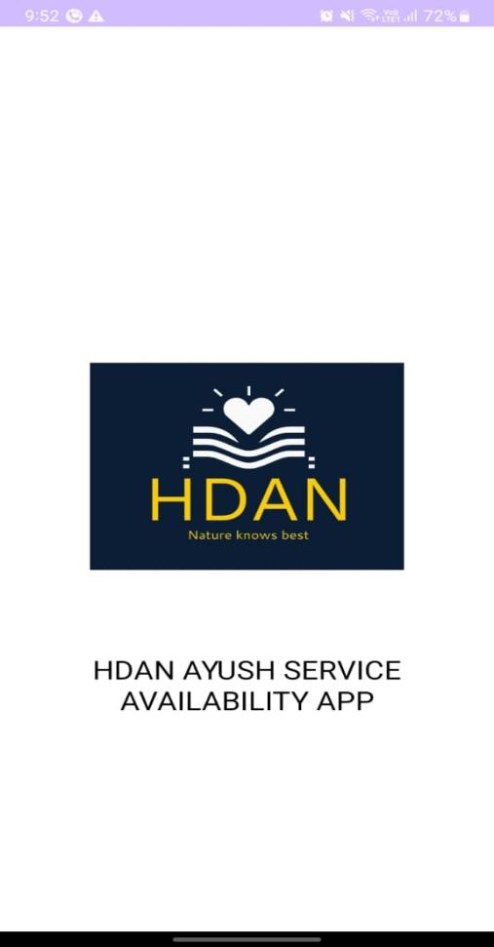 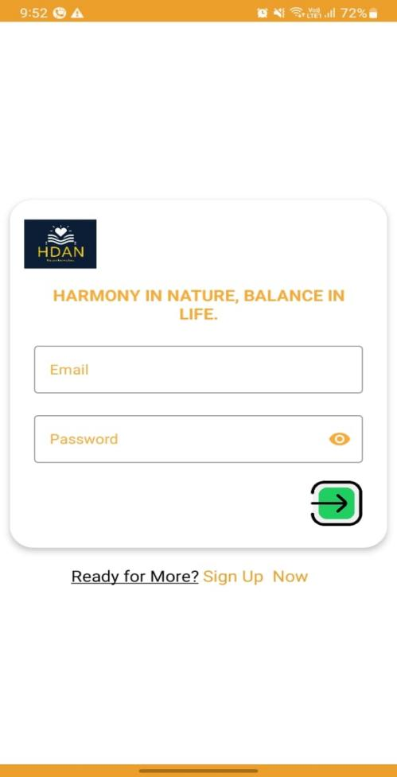

Fig: 5.1 App Opening Page Fig: 5.2 Login Page

**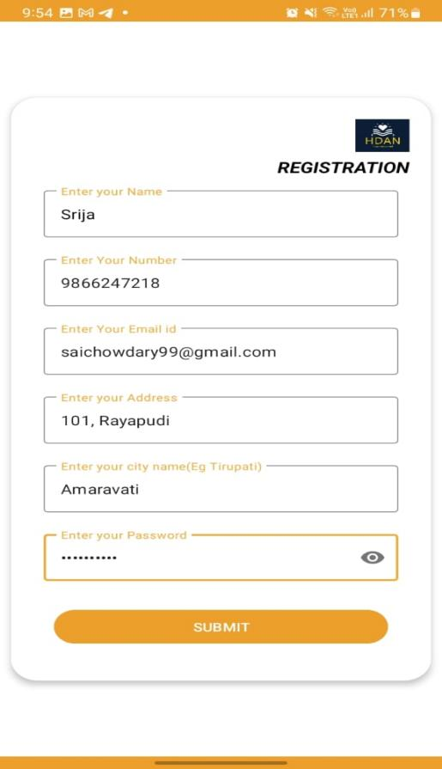 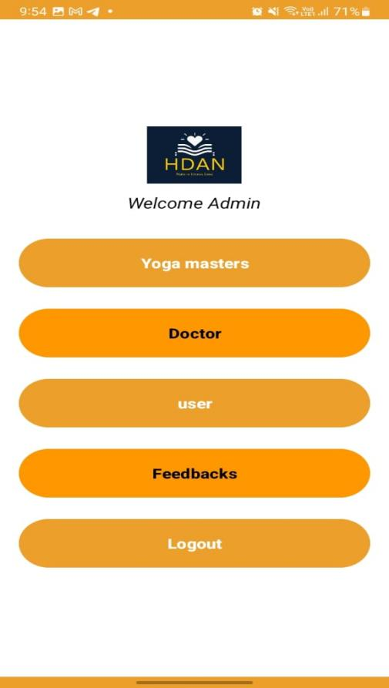**

Fig: 5.3 New User Registration Page Fig: 5.4 Admin Dashboard

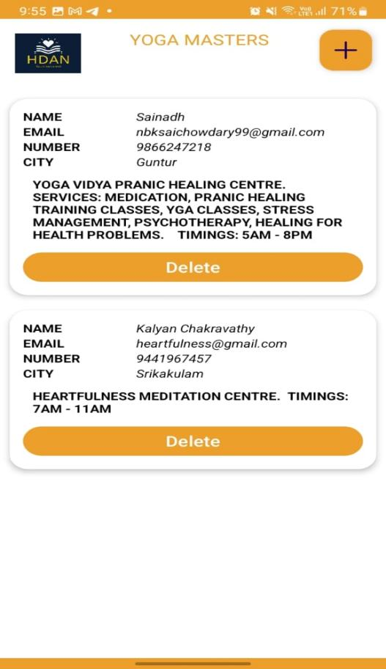 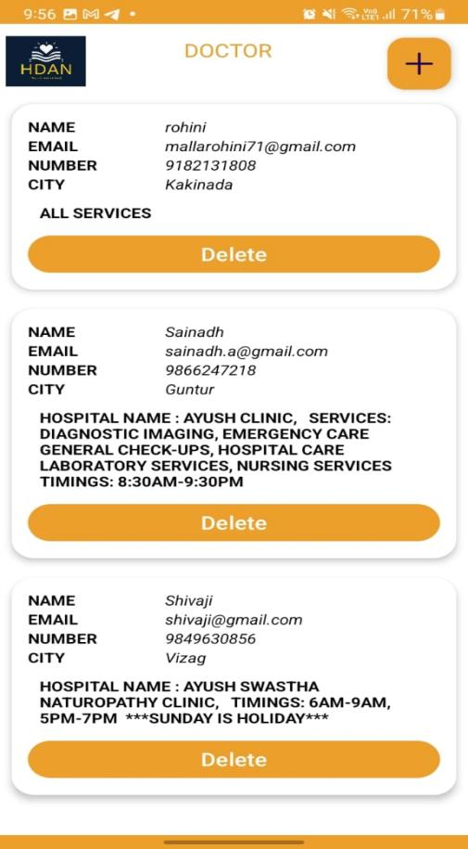

Fig: 5.5 Admin -> Yoga masters Fig: 5.6 Admin -> Doctors

**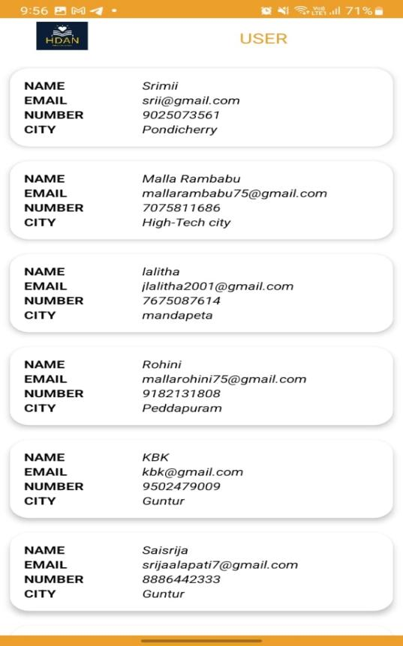 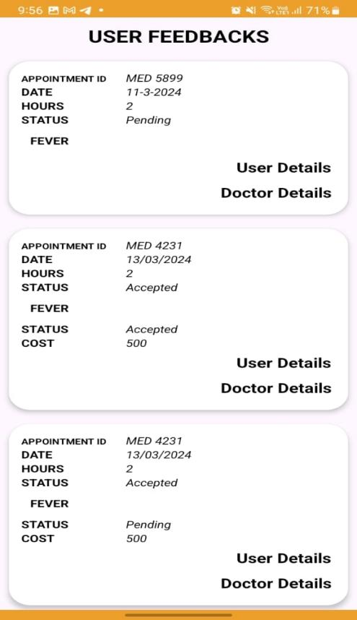**

Fig: 5.7 Admin -> Users Fig: 5.8 User Feedbacks

**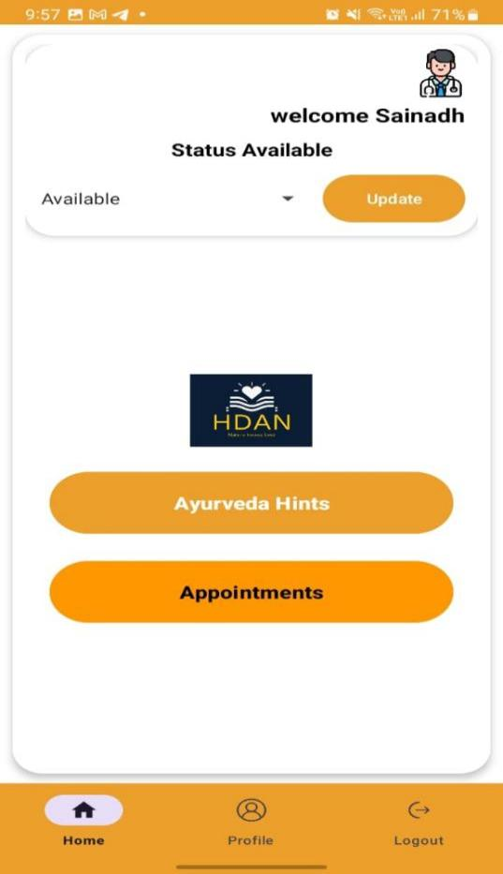 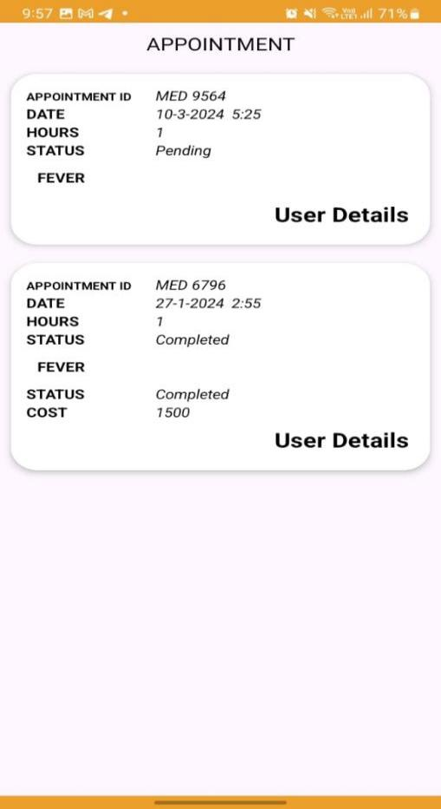**

Fig: 5.9 Doctor Dashboard Fig: 5.10 Doctor -> Appointment

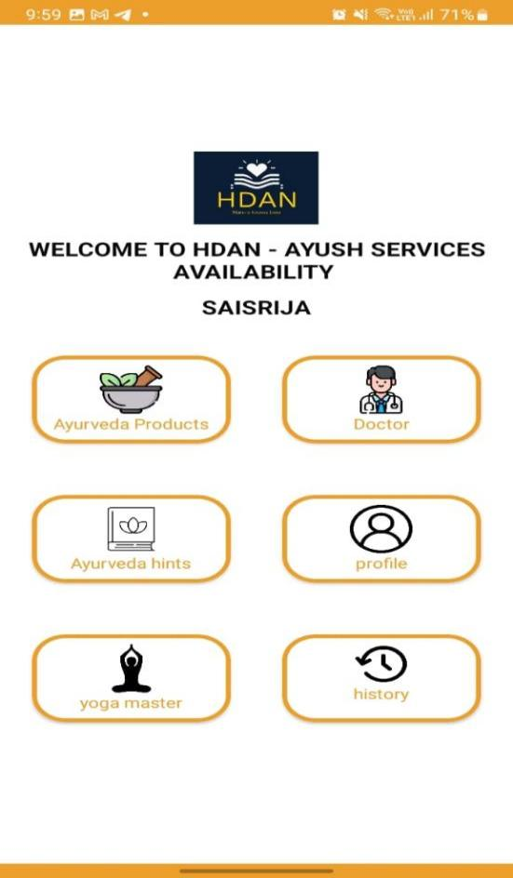 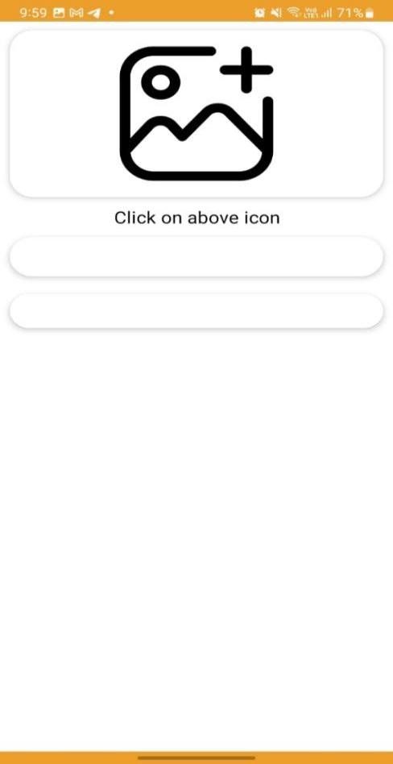

Fig: 5.11 User Dashboard Fig: 5.12 User -> Ayurveda Products

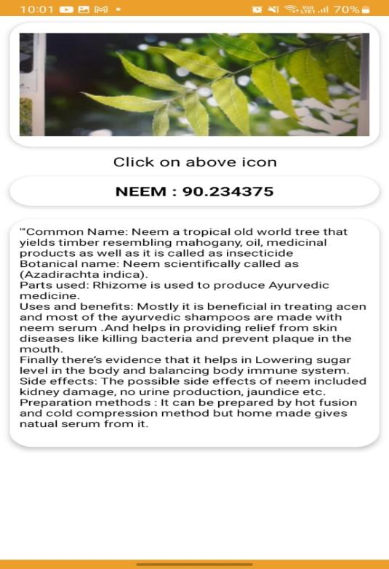 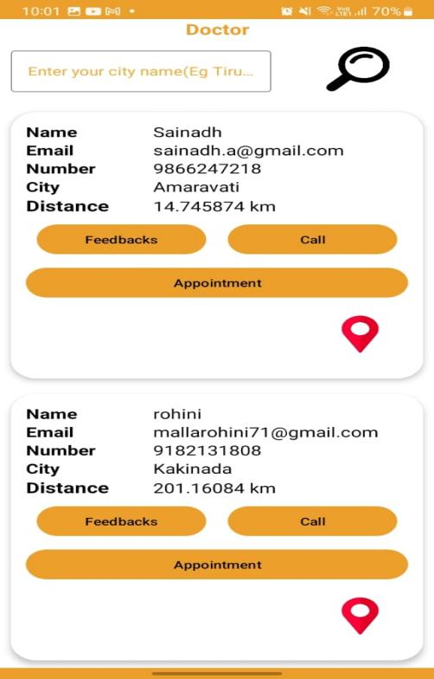

Fig: 5.13 User -> Ayurveda Products Fig: 5.14 User -> Doctor

-> Picture Search

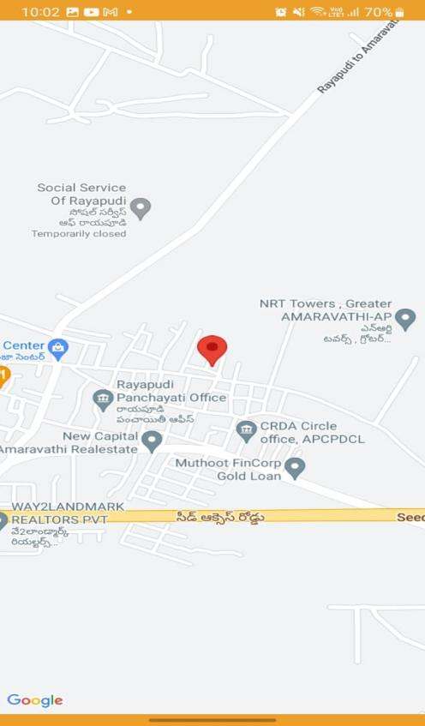 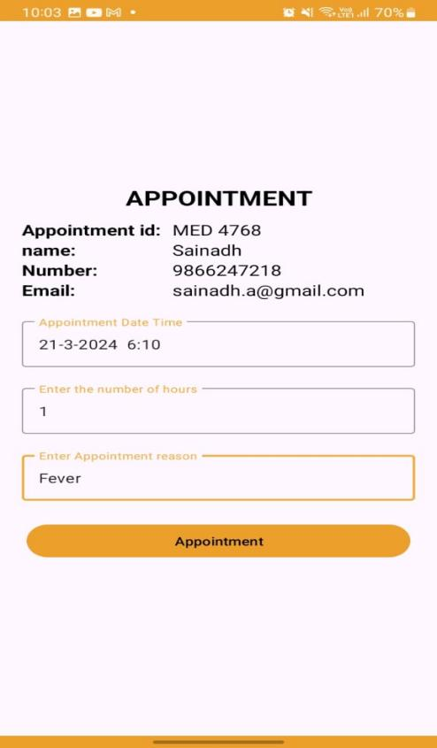

Fig: 5.15 User -> Doctor’s Location Fig: 5.16 User -> Appointment

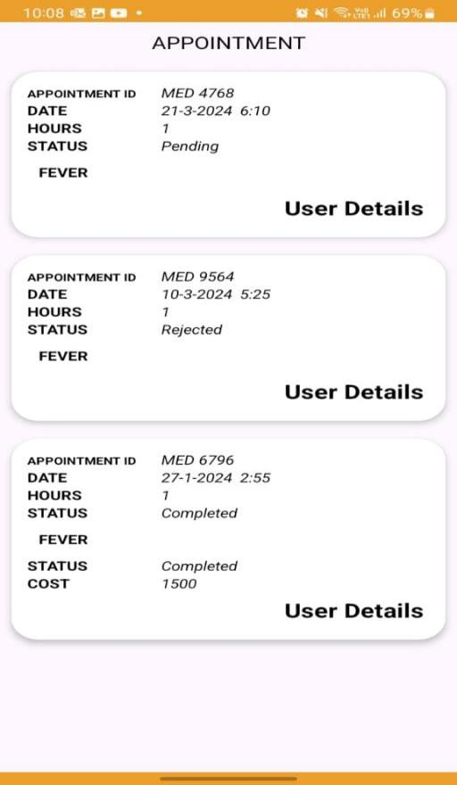 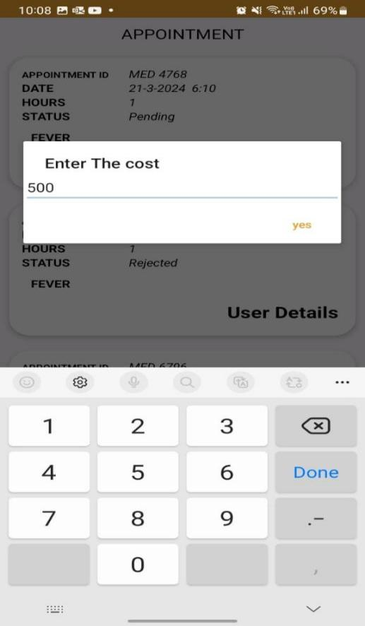

Fig: 5.17 User’s Appointment History Fig: 5.18 Doctor’s Cost Updation

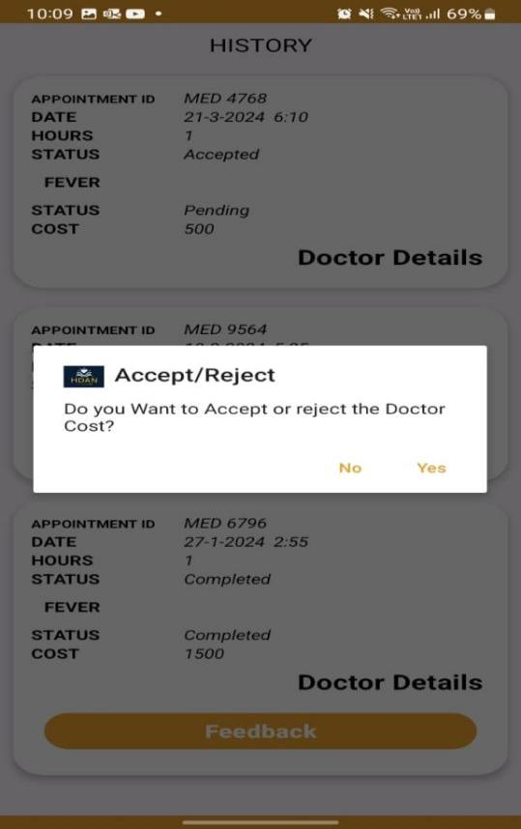 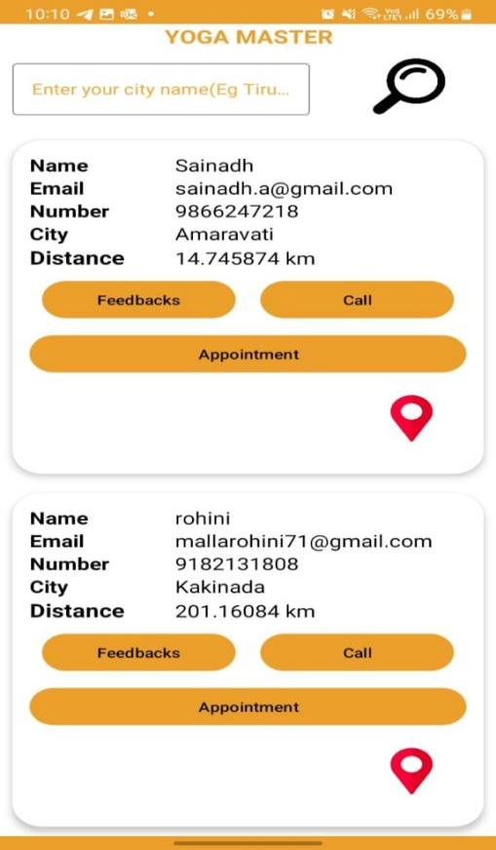

Fig: 5.19 User can accept/reject Fig: 5.20 User -> Yoga master

Appointment based on cost updated

By the doctor

**CHAPTER 6**

**CONCLUSION AND FUTURE SCOPE**

In conclusion, our Android application emerges as a transformative force in healthcare, bridging the gap between users, administrators, and healthcare professionals. With an emphasis on user convenience and advanced functionalities, the app redefines how we approach holistic well-being. The seamless integration of features like appointment scheduling, image recognition for Ayurveda insights, and secure portals for doctors ensures a comprehensive and user-centric healthcare experience by fostering efficient communication between administrators, doctors, and users, the application creates a connected ecosystem that prioritizes personalized care. As we navigate the evolving landscape of healthcare, this platform stands out as a beacon of innovation, empowering individuals to take charge of their well-being. In the realms of both traditional and modern healthcare practices, our Android app not only streamlines processes but also enriches the overall healthcare journey, contributing to a healthier and more interconnected society. Embrace the future of healthcare with our app, where user-centric design meets cutting-edge technology for a holistic and transformative healthcare experience.

Future enhancements for our Android application include integrating telemedicine capabilities for virtual consultations, expanding the database of healthcare professionals, and incorporating personalized health tracking features. We aim to implement AI-driven health recommendations based on user data, enhancing preventive care. Additionally, a community forum for users to share experiences and insights will be introduced, fostering a collaborative healthcare ecosystem. These updates will elevate the app's functionality, ensuring it continues to evolve as a pioneering force in the realm of comprehensive healthcare management.

**CHAPTER 7**

**REFERENCES**

[1] Aastha Zade, Gauri Chaudhari, Khyati Raghvani, Sakshi Bodke, Prof.G.R.Shinde, Ayurvedacharya App, 2022

[2] Nagashree M Annigeri, Pramod Sunagar,"AYURVEDA UPACHARA-AN ANDROID APP",2018

[3] D.B. Anantha Narayana and Sharanbasappa Durg,"Ayurveda: (W)here is the evidence",2021

[4] A.D.A.D.S. Jayalath; P.V.D. Nadeeshan; T.G.A.G.D Amarawansh; H.P Jayasuriya; D. P. Nawinna, Ayurvedic Knowledge Sharing Platform with Sinhala Virtual Assistant,2019

[5] Ayan Banerjee,Sandeep K. S. Gupta,"Analysis of Smart Mobile Applications for Healthcareunder Dynamic Context Changes",2014

[6] Busssadee,S.,Suwannatria,S.,Chonrawut,A.Thamwiwatthana, E., & Pasupa, Inside Me: A proposal for healthcare mobile application. 2016

[7] Almotiri, S. H., Khan, M. A., & Alghamdi, M. A. (2016). Mobile Health (m-Health) System in the Context of IoT. 2016.

[8] Suresh, Yeresime, T. Vineeth Kumar, Firdous Afreen, Mohammed Muniruddin, and Cheella Ashwith Kumar. "AAYU APP-Mobile Application for Healthcare Management System." ,2020.

[9] Luschi, Alessio, Andrea Belardinelli, L. Marzi, Francesco Frosini, Roberto Miniati, and Ernesto Iadanza. "Careggi Smart hospital: A mobile app for patients, citizens and healthcare staff." 2014.

[10] Ponmalar, A., S. Maansi, S. Mahalakshmi, M. Shalini, and Rinthya Madhavan. "Mobile

**APPENDIX**

**Published Article Certificates**

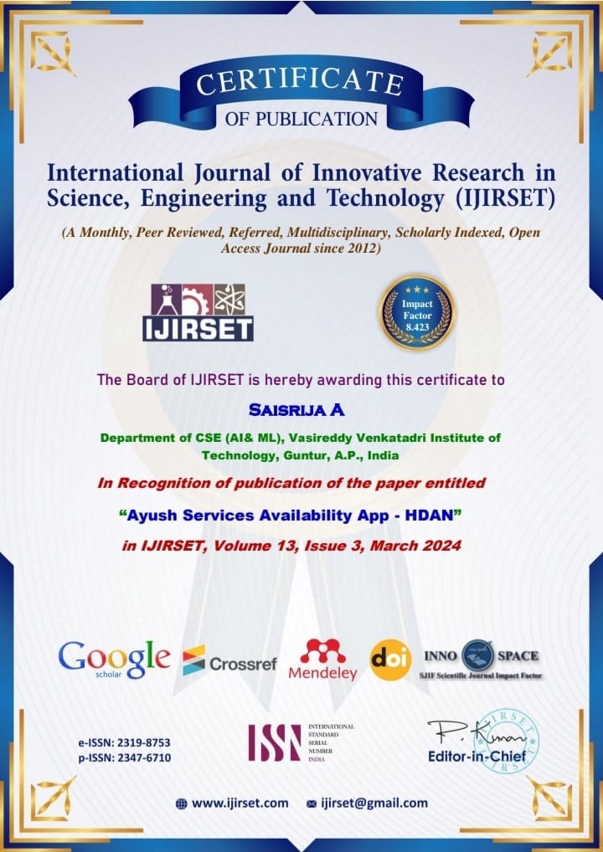

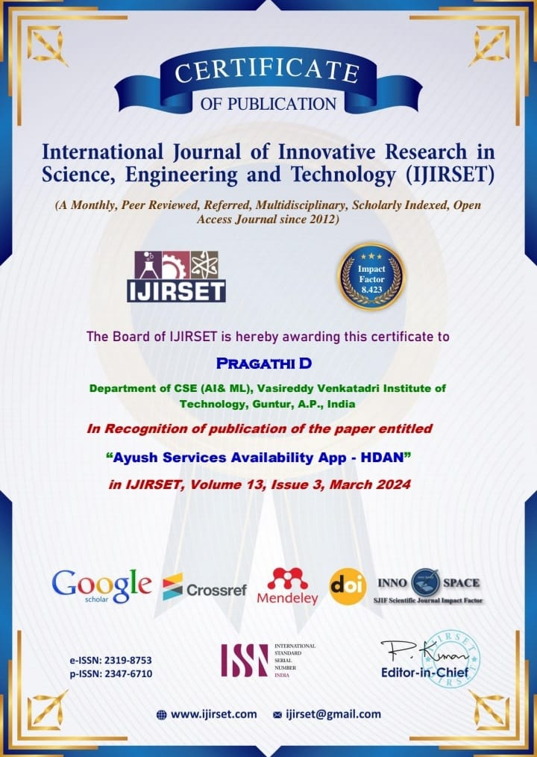

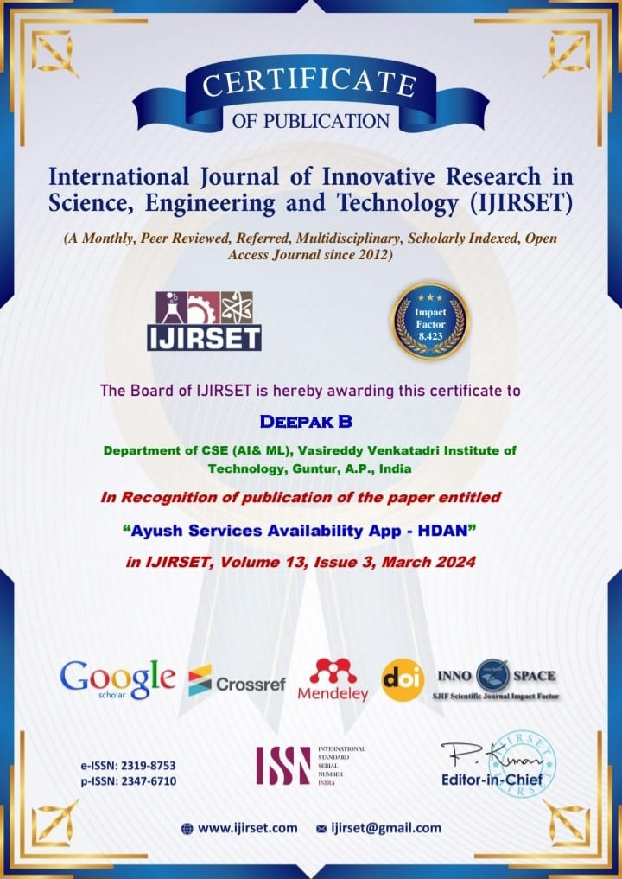

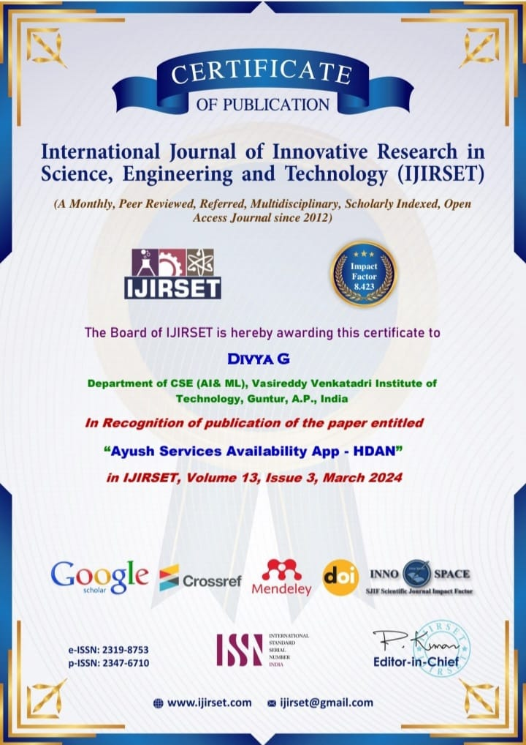



58

Impact Factor: 8.423

**Ayush Services Availability App - HDAN**

**Saisrija A1, Pragathi D2, Deepak B3, Divya G4, Gnanendra K5**

Department of CSE(AI&ML), Vasireddy Venkatadri Institute of Technology, Guntur, Andhrapradesh, India1,2,3,4

Assistant Professor, Department of CSE(AI&ML), Vasireddy Venkatadri Institute of Technology, Guntur, Andhrapradesh, India5

**ABSTRACT:** The Android application serves as a comprehensive healthcare management system, catering to both users and administrators. Admin privileges include the ability to add doctors and yoga masters, as well as view appointments and user profiles. Users, upon registration, can log in using their email and password, allowing them to explore nearby doctors and yoga masters, access Ayurveda hints, and schedule appointments. The app also facilitates users in uploading Ayurveda-related pictures, with an embedded image recognition feature providing insightful hints. For doctors, the application provides a secure login portal where they can access their appointments, updating appointment statuses and costs. This user-friendly platform ensures efficient management of healthcare services, fostering seamless communication between administrators, doctors, and users. Overall, the app combines user convenience with advanced features, contributing to a holistic healthcare experience.

**KEYWORDS:** Mobile application, Android

# **INTRODUCTION**

Designed to cater to both users and administrators, this comprehensive platform redefines the way we approach healthcare services. Seamlessly integrating advanced features and user-friendly interfaces, our app empowers administrators with privileged access to add doctors and yoga masters, view appointments, and manage user profiles. This centralized control ensures efficient healthcare administration, fostering streamlined communication among administrators, doctors, and users. For users, the journey begins with a simple registration process, unlocking a world of possibilities. The app offers a personalized experience, allowing users to explore nearby doctors and yoga masters, access invaluable Ayurveda hints, and conveniently schedule appointments. What sets this application apart is its unique feature enabling users to upload Ayurveda-related pictures. The embedded image recognition technology provides insightful hints, enhancing the overall user experience and promoting a deeper understanding of holistic wellness practices. Doctors, too, benefit from a secure login portal, providing them with a dedicated space to manage appointments, update statuses, and monitor costs. This collaborative platform fosters a sense of community and connectivity,

**IJIRSET©2024 |An ISO 9001:2008 Certified Journal| 2049**

ensuring that healthcare services are not just efficient but also tailored to individual needs.

## **1.1 Motivation**

Revolutionize healthcare with our Android app, a groundbreaking management system connecting users, administrators, doctors, and yoga masters. Admins effortlessly add healthcare professionals and oversee appointments, while users access nearby experts, Ayurveda insights, and appointment scheduling. The app's image recognition feature enhances Ayurveda experiences, and doctors’ benefit from a secure portal for managing appointments. With a focus on user-friendly design, this app transforms healthcare into a seamless, holistic journey for all.

## **1.2 Problem Statement**

## The problem addressed is the lack of a streamlined healthcare management system. This Android app aims to bridge the gap by enabling admins to manage professionals, users to access nearby healthcare providers, schedule appointments, and utilize image recognition for Ayurveda hints, thereby enhancing overall healthcare efficiency.

## **1.3 Objective of the Project**

The objective is to enhance accessibility, convenience, and communication in healthcare, ensuring users receive personalized and efficient services. The incorporation of image recognition adds an innovative dimension, furthering the app's commitment to holistic healthcare solutions.

## **1.4 Scope**

The scope of the Android application encompasses the seamless management of healthcare services, allowing administrators to efficiently add and monitor doctors and yoga masters. Users can easily find nearby healthcare professionals, schedule appointments, and utilize image recognition for Ayurveda hints.

1. **LITERATURE SURVEY**

## **Aastha Zade, Gauri Chaudhari, Khyati Raghvani, Sakshi Bodke, Prof.G.R.Shinde, Ayurvedacharya App, 2022**

In Ayurvedic Medicine is a system of traditional medicine native to Indians and is a form of alternative medicine. Ayurveda makes the use of plants-based medicine and treatments. Ayurvedic therapy is taken by controlling food habits, taking necessary foods for curing the disease and controlling daily life style. Ayurvedic Remedies are now widely accepted throughout the world. Most of the ingredients of any Ayurvedic Cures can be found at home easily. So, cures are not very costly and can be done easily.

## **Nagashree m annigeri, pramod sunagar,"ayurveda upachara-an android app",2018**

Ayurvedic Medicine is a system of traditional medicine native to Indians and is a form of

**IJIRSET©2024 |An ISO 9001:2008 Certified Journal| 2050**

alternative medicine. Ayurveda makes the use of plants-based medicine and treatments. Ayurvedic therapy is taken by controlling food habits, taking necessary foods for curing the disease and controlling daily life style. Ayurvedic Remedies are now widely accepted throughout the world. Most of the ingredients of any Ayurvedic Cure can be found in home easily.

## **2.3. D.B. Anantha Narayana and Sharanbasappa Durg,"Ayurveda: (W)here is the evidence",2021**

Ayurveda lacks scientific evidence. By scientific evidence, it is commonly referred to results of human clinical trials undertaken adoring those applied to pharmaceuticals, involving randomized controlled trials (RCT), either a placebo or active controlled. This paper explores the actual situation related to practice of Ayurveda, use of medicines, application of therapies, and the individual dravyas (ingredients). It gives few examples and availability of large body of scientific data in this area. The study, however, does not discuss the reasons and problems of conducting RCTs.

## **2.4.A.D.A.D.S. Jayalath; P.V.D. Nadeeshan; T.G.A.G.D Amarawansh; H.P Jayasuriya; D. P. 2.5.Nawinna, Ayurvedic Knowledge Sharing Platform with Sinhala Virtual Assistant,2019**

In this Ayurveda methods identification of indigenous plants to predict the medicines is very important and must do very carefully. Generally main components that we use to identify a plant are leaf, flower, trunk and root etc. Among these features, we use images of leaves and flowers. To do this we are using deep learning-based CNN approaches. Another useful feature of this system is it provides relevant information of Ayurveda doctors. So, users can find doctors according to their needs and they are able to rate and give recommendations for the doctors. That will be help others to find doctors more easily and efficiently without any doubt.

**2.6.Ayan Banerjee,Sandeep K. S. Gupta,"Analysis of Smart Mobile Applications for Healthcareunder Dynamic Context Changes",2014**

This paper proposes a novel technique to analyze SMDCS taking into account the dynamic changes in the context and the constant interaction of the computing systems with the physical environment. To show the usage of the technique, Ayushman pervasive health monitoring system is considered as an example SMDCS. Analytical results show that practices considered healthy for a person such as mobility may not be beneficial when an SMDCS is controlling health.

1. **SYSTEM ANALYSIS**

## **3.1 Existing System:**

The current healthcare system lacks a centralized platform, resulting in inefficiencies such as cumbersome appointment scheduling, limited accessibility to healthcare providers, and a

**IJIRSET©2024 |An ISO 9001:2008 Certified Journal| 2051**

lack of integration between administrators, doctors, and users. User experiences are hindered by the absence of a streamlined process for finding nearby professionals and managing appointments.

**Disadvantages of Existing System**

1. Lack of integration between administrators, doctors, and users.
2. Inefficient user experiences.
3. Absence of features like image recognition for Ayurveda hints.
4. Disjointed healthcare processes.

**3.2. Proposed System:**

The proposed Android application revolutionizes healthcare management by offering a centralized platform. Admins can effortlessly add and oversee doctors and yoga masters. Users benefit from streamlined appointment scheduling, proximity-based searches for healthcare providers, and an innovative image recognition feature providing Ayurveda insights. The app ensures a user-friendly experience, allowing patients to easily find nearby professionals, schedule appointments, and upload images for personalized hints. For doctors, it provides a secure platform to manage appointments efficiently. The proposed system aims to create a cohesive healthcare ecosystem, enhancing accessibility, communication, and overall user satisfaction in the healthcare journey.

**Advantages of Proposed System**

1. Effortless addition and oversight of doctors and yoga masters by administrators.
2. Streamlined appointment scheduling for users.
3. Proximity-based searches for healthcare providers.
4. Innovative image recognition for Ayurveda insights.
5. User-friendly experience with easy appointment scheduling and personalized hints.
6. Secure platform for doctors to efficiently manage appointments.

**ARCHITECTURE**

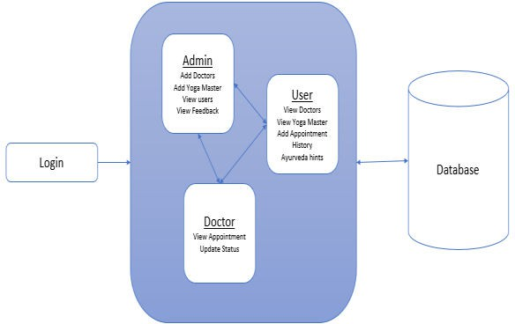 Fig: 3.2.1 Architecture

**IJIRSET©2024 |An ISO 9001:2008 Certified Journal| 2052**

## **METHODOLOGY**

## **4.1 Front-end Technology :**

Modern terminology has made the novel system development a very important component. As it outlines both designing and coding methodologies, we are applying both traditional methods and cutting-edge new ones. Since all technologies are moving in the direction of APIs, their significance is anticipated to increase quickly. Java is utilized in this instance to run the project dynamically and for finding the best route from the patient’s location, we have used the KNN algorithm.

## **4.2 K- Neareast Neighbour Algorithm:**

An introduction to the classifier is the K-nearest neighbour classifier. This algorithm is dependent on the customer’s location. It uses neurons as its node to identify the output node, and it uses the shortest path approach. Each node indicates the driver’s position, whereas the output node reflects the client’s location. Locations of hospitals are indicated by latitude, longitude, or point (x, y) coordinates. The function searches for the nearest neighbour(s) using an array of these places. The closest hospital’s index is returned, and the Pythagorean theorem can be used to determine its distance. First we have to find the k nearest neighbours of points and return the indexes of nearest neighbour k. Utilizing the coordinates of these ordered pairs and the formula below, determine the distance between two points (x1, y1) and (x2, y2) by using their coordinates .

Distance= √[(x2 − x1)2 + (y2 − y1)2] (1)

Additionally, if we had access to the API that returned the longitude and latitude of the hospital’s location, we could determine the precise distance in miles or kilometres to the hospital.

## **4.3 Google APIs for Location:**

A powerful mapping platform service developed by Google is called Google Maps API. This mapping service can be incorporated by the developers into any program or website. Additionally, developer data may be connected with this service. This service provides information on detailed street maps and imagery. Data on distance and anticipated trip times are also available. To embed Google Maps in a particular website or application, an API key is needed. To use this service and create an API key, we need a Google account. The following form is provided by the Google Maps library: com. google. Android. gms. Map View and Map Fragment classes both display the map component.

**IJIRSET©2024 |An ISO 9001:2008 Certified Journal| 2053**

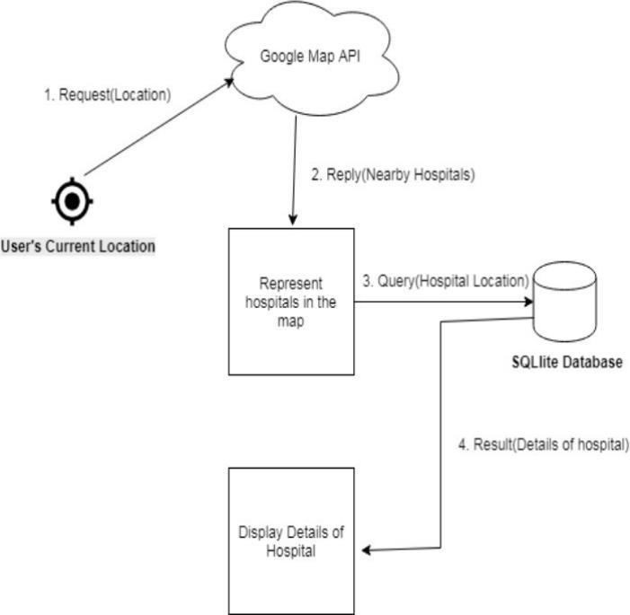

Fig 4.3.1

## **4.4 Firebase:**

With the help of Firebase, we can create web applications without using server-side programming, making the development process simpler and faster. In its free edition, a single Firebase node provides up to 100 connections per second. For more than 3000 INR, the paid edition enables hosting and bespoke domains. Developers can use Firebase to complete all necessary tasks, including authenticating users, storing data, and putting in place access controls. Firebase uses NoSQL to store data, which is organised into pairs of keys. Developers can use the Firebase Cloud Messaging capability as well. Firebase offers an additional 1 Gigabyte of storage space and up to 10 Gigabytes of data transport for your database.

1. **SYSTEM DESIGN**

**INPUT DESIGN**

The input design is the link between the information system and the user. It comprises the developing specification and procedures for data preparation and those steps are necessary to put transaction data in to a usable form for processing can be achieved by inspecting the computer to read data from a written or printed document or it can occur by having people keying the data directly into the system. The design of input focuses on controlling the amount of input required, controlling the errors, avoiding delay, avoiding extra steps and keeping the process simple. The input is designed in such a way so that it provides security

**IJIRSET©2024 |An ISO 9001:2008 Certified Journal| 2054**

and ease of use with retaining the privacy. Input Design considered the following things:

* What data should be given as input?
* How the data should be arranged or coded?
* The dialog to guide the operating personnel in providing input.
* Methods for preparing input validations and steps to follow when error occur.

**OBJECTIVES**

1. Input Design is the process of converting a user-oriented description of the input into a computer-based system. This design is important to avoid errors in the data input process and show the correct direction to the management for getting correct information from the computerized system.
2. It is achieved by creating user-friendly screens for the data entry to handle large volume of data. The goal of designing input is to make data entry easier and to be free from errors. The data entry screen is designed in such a way that all the data manipulates can be performed. It also provides record viewing facilities.
3. When the data is entered it will check for its validity. Data can be entered with the help of screens. Appropriate messages are provided as when needed so that the user will not be in maize of instant. Thus the objective of input design is to create an input layout that is easy to follow

**OUTPUT DESIGN**

A quality output is one, which meets the requirements of the end user and presents the information clearly. In any system results of processing are communicated to the users and to other system through outputs. In output design it is determined how the information is to be displaced for immediate need and also the hard copy output. It is the most important and direct source information to the user. Efficient and intelligent output design improves the system’s relationship to help user decision-making.

1. Designing computer output should proceed in an organized, well thought out manner; the right output must be developed while ensuring that each output element is designed so that people will find the system can use easily and effectively. When analysis design computer output, they should Identify the specific output that is needed to meet the requirements.
2. Select methods for presenting information.
3. Create document, report, or other formats that contain information produced by the system.

The output form of an information system should accomplish one or more of the following objectives.

* + Convey information about past activities, current status or projections of the
  + Future.
  + Signal important events, opportunities, problems, or warnings.
  + Trigger an action.
  + Confirm an action.

**IJIRSET©2024 |An ISO 9001:2008 Certified Journal| 2055**

# **IMPLEMENTATION**

## **6.1 Modules**

**Admin:** The admin will login into the app. to add new doctors. the addition of yoga masters. Enables administrators to monitor and manage appointment details.

**Doctors:** The doctor will login with in email and passwords. He can view Appointment and Update the status and cost of the Appointment.

**User:** The user will register with his details, he can login with his email and password. He can view nearby yoga master and doctors. He can view the Ayurveda Hint and add the appointment with doctors and view history of the appointment. The users to upload images related to Ayurveda. image recognition to analyse pictures and offer relevant hints.

1. **RESULTS**

Building a “AYUSH” hospitals finder application that displays the location and nearby AYUSH hospitals with opening and closing times while integrating various biomedical data sources with information on the hospital’s demographics, inpatient procedure rates, and outpatient department is the project’s proposed work, Etc. This study demonstrates that when three elements are taken into account—the radius value, journey distance, and travel time—better decisions are made than when simply the radius value is taken into account. The researchers' suggested approach also shares 95% of its characteristics with human decision-making.

**7.1 Testcases:**

**Test strategy and approach**

Field testing will be performed manually and functional tests will be written in detail.

**Test Objectives**

* + - All field entries must work properly.
    - Pages must be activated from the identified link.
    - The entry screen, messages and responses must not be delayed.

## **Features to be tested**

* + - Verify that the entries are of the correct format
    - No duplicate entries should be allowed
    - All links should take the user to the correct page.

**INTEGRATION TESTINGS**

Software integration testing is the incremental integration testing of two or more integrated software components on a single platform to produce failures caused by interface defects. The task of the integration test is to check that components or software applications, e.g., components in a software system or – one step up – software applications at the company level – interact without error.

**Test Results:** All the test cases mentioned above passed successfully. No defects encountered.

**IJIRSET©2024 |An ISO 9001:2008 Certified Journal| 2056**

# **ACCEPTANCE TESTING**

User Acceptance Testing is a critical phase of any project and requires significant participation by the end user. It also ensures that the system meets the functional requirements.

|  |  |
| --- | --- |
| **Functionality** | **Result** |
| Check to see whether spinning the device works on all app stages and displays. | Passed |
| Check sure the application is operating as required when it begins or finishes. | Passed |
| Check to see if the application follows the specifications while switching between modules. | Passed |
| Make sure you can return from any screen to the previous one. | Passed |

Table 7.1.1 Testcase - 1

|  |  |
| --- | --- |
| **Compatibility** | **Result** |
| Make sure that the program is running while making sure the device can still receive calls and texts. | Passed |
| Whether a device allows the removal of an application. | Passed |

Table 7.1.2 Testcase - 2

**IJIRSET©2024 |An ISO 9001:2008 Certified Journal| 2057**

|  |  |  |  |
| --- | --- | --- | --- |
| **Action** | **Expected Result** | **Actual Result** | **Remark** |
| App start-up time | 2000ms | 2000ms | Passed |
| Memory consumption for Application | 120-190  Mb | 134Mb | Passed |
| Network Speed Per Read/write. | 12 kbps-1 Mbps | 134Mb | Passed |
| Response time for read | 134Mb | 134Mb | Passed |

Table 7.1.3 Testcase - 3

# **CONCLUSION**

# In conclusion, our Android application emerges as a transformative force in healthcare, bridging the gap between users, administrators, and healthcare professionals. With an emphasis on user convenience and advanced functionalities, the app redefines how we approach holistic well-being. The seamless integration of features like appointment scheduling, image recognition for Ayurveda insights, and secure portals for doctors ensures a comprehensive and user-centric healthcare experience by fostering efficient communication between administrators, doctors, and users, the application creates a connected ecosystem that prioritizes personalized care. As we navigate the evolving landscape of healthcare, this platform stands out as a beacon of innovation, empowering individuals to take charge of their well-being. In the realms of both traditional and modern healthcare practices, our Android app not only streamlines processes but also enriches the overall healthcare journey, contributing to a healthier and more interconnected society. Embrace the future of healthcare with our app, where user-centric design meets cutting-edge technology for a holistic and transformative healthcare experience.

# **FUTURE ENHANCEMENT**

Future enhancements for our Android application include integrating telemedicine capabilities for virtual consultations, expanding the database of healthcare professionals, and incorporating personalized health tracking features. We aim to implement AI-driven health recommendations based on user data, enhancing preventive care. Additionally, a community

**IJIRSET©2024 |An ISO 9001:2008 Certified Journal| 2058**

forum for users to share experiences and insights will be introduced, fostering a collaborative healthcare ecosystem. These updates will elevate the app's functionality, ensuring it continues to evolve as a pioneering force in the realm of comprehensive healthcare management.

# **REFERENCES**

1. Aastha Zade, Gauri Chaudhari, Khyati Raghvani, Sakshi Bodke, Prof.G.R.Shinde, Ayurvedacharya App, 2022
2. Nagashree M Annigeri, Pramod Sunagar,"AYURVEDA UPACHARA-AN ANDROID APP",2018
3. D.B. Anantha Narayana and Sharanbasappa Durg,"Ayurveda: (W)here is the evidence",2021
4. A.D.A.D.S. Jayalath; P.V.D. Nadeeshan; T.G.A.G.D Amarawansh; H.P Jayasuriya; D. P. Nawinna, Ayurvedic Knowledge Sharing Platform with Sinhala Virtual Assistant,2019
5. Ayan Banerjee,Sandeep K. S. Gupta,"Analysis of Smart Mobile Applications for Healthcareunder Dynamic Context Changes",2014
6. Busssadee,S.,Suwannatria,S.,Chonrawut,A.Thamwiwatthana, E., & Pasupa, Inside Me: A proposal for healthcare mobile application. 2016
7. Almotiri, S. H., Khan, M. A., & Alghamdi, M. A. (2016). Mobile Health (m-Health) System in the Context of IoT. 2016.
8. Suresh, Yeresime, T. Vineeth Kumar, Firdous Afreen, Mohammed Muniruddin, and Cheella Ashwith Kumar. "AAYU APP-Mobile Application for Healthcare Management System." ,2020.
9. Luschi, Alessio, Andrea Belardinelli, L. Marzi, Francesco Frosini, Roberto Miniati, and Ernesto Iadanza. "Careggi Smart hospital: A mobile app for patients, citizens and healthcare staff." 2014.
10. Ponmalar, A., S. Maansi, S. Mahalakshmi, M. Shalini, and Rinthya Madhavan. "Mobile Application for Hospital Management System”,2021.

**IJIRSET©2024 |An ISO 9001:2008 Certified Journal| 2059**

